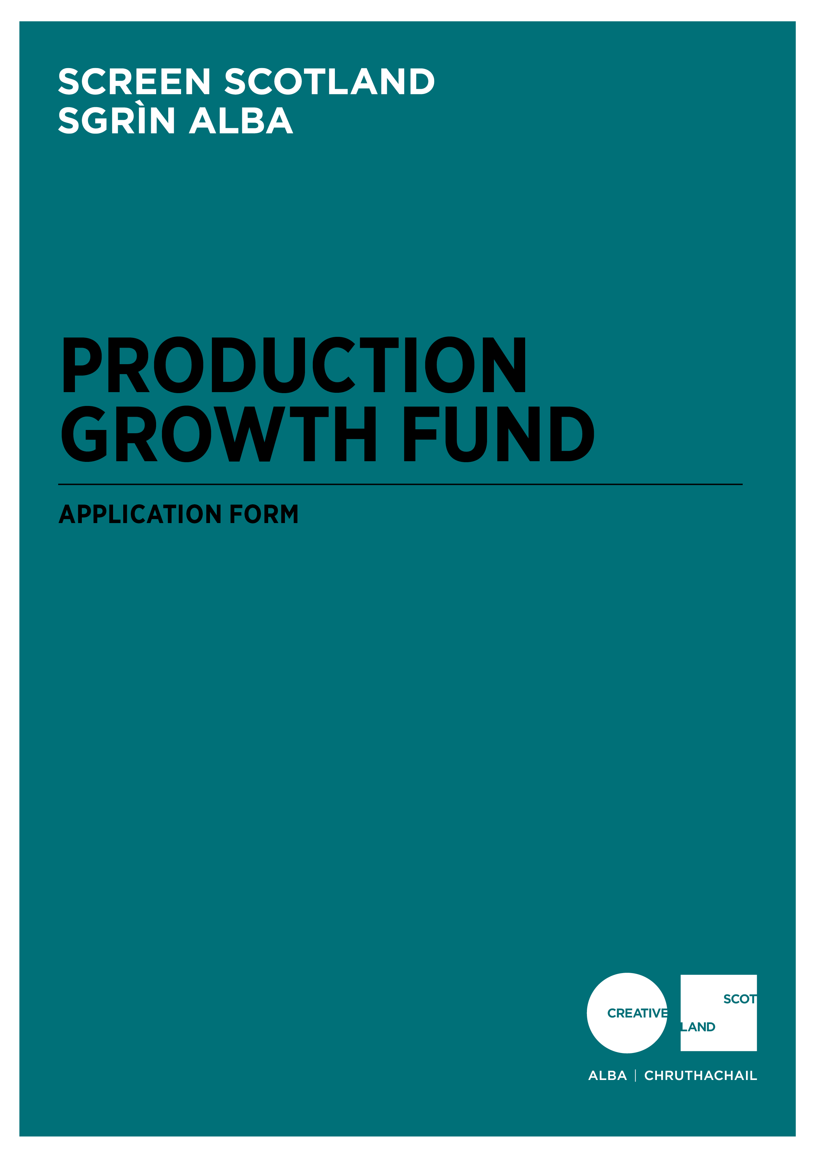

Application Form for the Production Growth Fund
Advice and Information
Please read the Production Growth Fund Guidance before making an application. If you have any general enquiries about the application process, guidelines or application form please contact us.
Data Protection
As part of your application Creative Scotland/Screen Scotland requires some personal information about you/your organisation, in order to consider your request for funding. If you would like to see a breakdown of the personal information we require, why it is required, what we do with that information and how long we keep it, please refer to the Funding Privacy Notice for this fund, available online at: www.creativescotland.com/funding/help-with-your-application/funding-privacy-notice
Alternative Formats, Languages and Access Support
We are committed to offering clear and accessible application processes and programmes that are open to everyone. On request this information is available in alternative formats including translations. We offer access support to disabled applicants, tailored to individual requests. Support includes Sign Language Interpreters for meetings and scribing support for dyslexic applicants. Officers can offer advice to new applicants and support them to make an application. The Equalities Team can offer additional one-to-one support to applicants with access requirements. Please note we will accept applications and supporting materials which are written in English, Gaelic or Scots.
If you have any further questions about this fund, please contact our Enquiries Service. You can do this by email, through our website or social media.
Email: enquiries@creativescotland.com
Web: fill out a form on our website
Twitter: send us a tweet @screenscots
If you are a deaf BSL user, you can access our services with the Contact Scotland-BSL programme. Go to www.contactscotland-bsl.org for more information.

Section A: Key Information
In order for us to be able to process your application, you need to complete Sections A-E and the Statement of Acceptance in this application form.
Please be advised, we will not be able to process your application if you do not answer all the questions.
Have you read the Production Growth Fund Guidance before completing this application form?  (Delete as appropriate) | Yes
 | No
Please confirm that you have read and understood Creative Scotland’s Funding Privacy Notice and any relevant information sheets before completing this application form  (Delete as appropriate) | Yes
 | No
Have you spoken to a member of Screen Scotland staff about your application before applying?  (Delete as appropriate) | Yes
 | No

Section B: Contact Information
Name of Applicant Company
Lead Contact Name and Position
Address
Postcode
Telephone Number
Email Address
Web Address
Trading Name of Organisation
What type of organisation are you? (Please type an X in the box in the right-hand column)  You must be one of these to apply.  We also need the information so we can monitor our decision making and report to Scottish Government on the types of organisations we fund). | Company Limited by Guarantee
 | Company Limited by Shares
 | Other (please specify)
Are you a registered company?  (Delete as appropriate) | Yes
 | No
If you are a registered company, please provide your Company Number

Section C: Project Summary
Project Title
Please summarise your project or activity.
If you are successful in receiving funding, we may use this information in any publicity we produce about your project or activity (100 words max)

Type of content  (Delete as appropriate) | Live-Action Feature Film  Animated Feature Film  Live-Action TV Drama Series  Animated TV Series  Factual Returnable Series
When will the project start?
(Please note: that you must apply at least 12 weeks before your anticipated first day of principal photography in Scotland.)

When do you expect the project to end?

Section D: Production Growth Fund Request
Please confirm acceptance that a successful award will be paid retrospectively  (Delete as appropriate) | Yes
 | No

What is the total budget of the project? | £
How much are you requesting from the Production Growth Fund?  (Please note: you can apply for any amount between £200k and £500k) | £
What percentage of the project’s total budget does the request represent? | %
How much committed co-funding is confirmed?  (Please note evidence of committed co-funding will be required as supporting documents) | £
What is the Estimated Scottish Spend budget?  (Refer to Appendix C in the fund guidance, for more information) | £
What is the Estimated Scottish Spend to funding requested ratio?  (Please note this should be no less than 10:1) | :

Please provide a short biography detailing any relevant experience or credits you have had in film and/or television (please provide details of any completed projects)
Number of feature films released theatrically:

Number of network television series broadcast:

Number of television series distributed internationally:

Provide the name(s) and place of residence of the key personnel on this project/activity including postcode.
Name of director(s) and place of residence including postcode.

Place of benefit
Please detail, as required below, the area(s) which will benefit from the production activity in Scotland
Where will the activity take place?  Please tell us as much information as you can about where your project will take place. We will expect you to fill out at least one of these boxes, but please complete as many as are applicable. | Postcodes:
 | Local Authority Areas:

Section E: Essential Materials
Please submit the following Essential Materials with your application form and confirm that each document has been submitted within the table below.
Detailed Full Production Budget
(Please note: this budget should allow for £15,000 towards Creative Scotland’s legal costs, per Funding Terms in the guidance)
Production Schedule
Post-Production Schedule
Finance Plan, including evidence of all committed finance
Estimated Scottish Spend Budget
(Refer to Appendix C in the fund guidance, for more information)
Training and Career Development Plan
(Refer to Appendix A in the fund guidance, for more information)
Equalities, Diversity and Inclusion (EDI) action plan
(Refer to Appendix B in the fund guidance, for more information)
All applicant companies must provide a copy of founding legal documents (for example Articles of Association, Trust Deeds, or written constitution)
All applicant companies with 10 or more employees, must provide an Equalities and Diversity policy, or Equal Opportunities Policy.
If you have an Equalities Plan, please submit this also.

Statement of Acceptance
PLEASE STATE THE NAME OF THE PERSON WHO HAS COMPLETED THE FORM. THIS PERSON MUST BE AN AUTHORISED SIGNATORY OF THE COMPANY OR ORGANISATION APPLYING.
I hereby confirm that the information in this application submission including the supporting documents is true and correct and I acknowledge that it is my responsibility to inform you immediately of any changes which could affect the interpretation or context of the application, and I confirm I will undertake to do this.
I acknowledge that the terms and conditions of this application and any other information supplied and discussed regarding this application, the assessment and decision making process, or in connection with this transaction as a whole (“the Confidential Information”) is and shall remain strictly confidential. I confirm that I shall not disclose to any third party or make public the Confidential Information without Creative Scotland’s prior written approval.
I acknowledge that Creative Scotland will endeavour to keep all information provided securely, but as a Public Authority in terms of the Freedom of Information (Scotland) Act 2002, may be required to disclose certain information under the Act. Where I stipulate at the time of providing information to Creative Scotland that I believe the information should be considered exempt from disclosure under that Act, and a request to Creative Scotland is subsequently made for disclosure of same or all of that information, Creative Scotland will endeavour to discuss such disclosure with me prior to making its decision. I do, however, accept and acknowledge that the ultimate decision on disclosure rests solely with Creative Scotland regardless of any prior statements or requests I have issued.
If any of the information I provide is classed as Personal Data under the Data Protection Act 1998; the General Data Protection Regulation (EU) 2016/679 of 27 April 2016 (GDPR); and any legislation supplementary to the GDPR introduced in the United Kingdom (the "Data"), I hereby consent that Creative Scotland may disclose said Data, within and outside of the European Economic Area, for the purposes of producing and submitting any statistical information and reports or as otherwise required by law or by any regulations and other rules to which we are subject.
I confirm that all cash and in-kind contributions from the company or my own personal resources stated in the finance plan and described in this application form are correct and that I have the authorisation to allocate the sums stated and I am responsible for ensuring that adequate resources will remain available to meet these requirements. In the event of any changes to the sums indicated I will provide a signed letter of confirmation.
I acknowledge that Creative Scotland is obliged to comply with Money Laundering Regulations 2007 and the Proceeds of Crime Act 2002 and I will, if requested, provide ID
verification from any investor or myself, where appropriate, to meet compliance requirements.
I acknowledge that once Creative Scotland have confirmed the Offer of Funding in writing (via email) that Creative Scotland have the right to publicise their Offer of Funding on the Creative Scotland website and through other Creative Scotland information channels. I understand that Creative Scotland’s Offer of Funding does not place Creative Scotland under any obligation to release funds until such time as all contractual negotiations are complete and Creative Scotland’s Conditions Precedent have been met and their Funding Agreements signed off.
I confirm that I will not make any public statements (or allow others to do so on my behalf) regarding Creative Scotland’s Offer of Funding until such time as Creative Scotland has authorised and approved the form and content of any public statement.
I confirm that I have the power to accept the award under the conditions set out in the Creative Scotland Guidelines and in this Application Form.
I declare that I have read and understood the Creative Scotland Guidelines, this Application Form and the Conditions of Funding of Creative Scotland.
I hereby confirm acceptance of the above Statement of Acceptance and all related documents. (double click and mark as checked)
………………………………………………………
Name of Authorised Person
………………………………………………………
Position of Authorised Person
………………………………………………………
Date

Please now submit your completed application form to: screen@creativescotland.com

Please also complete your Equalities Monitoring Form and email it along with your application form. Please note: the Equalities Monitoring Form is anonymous and will be processed separately from your application.

