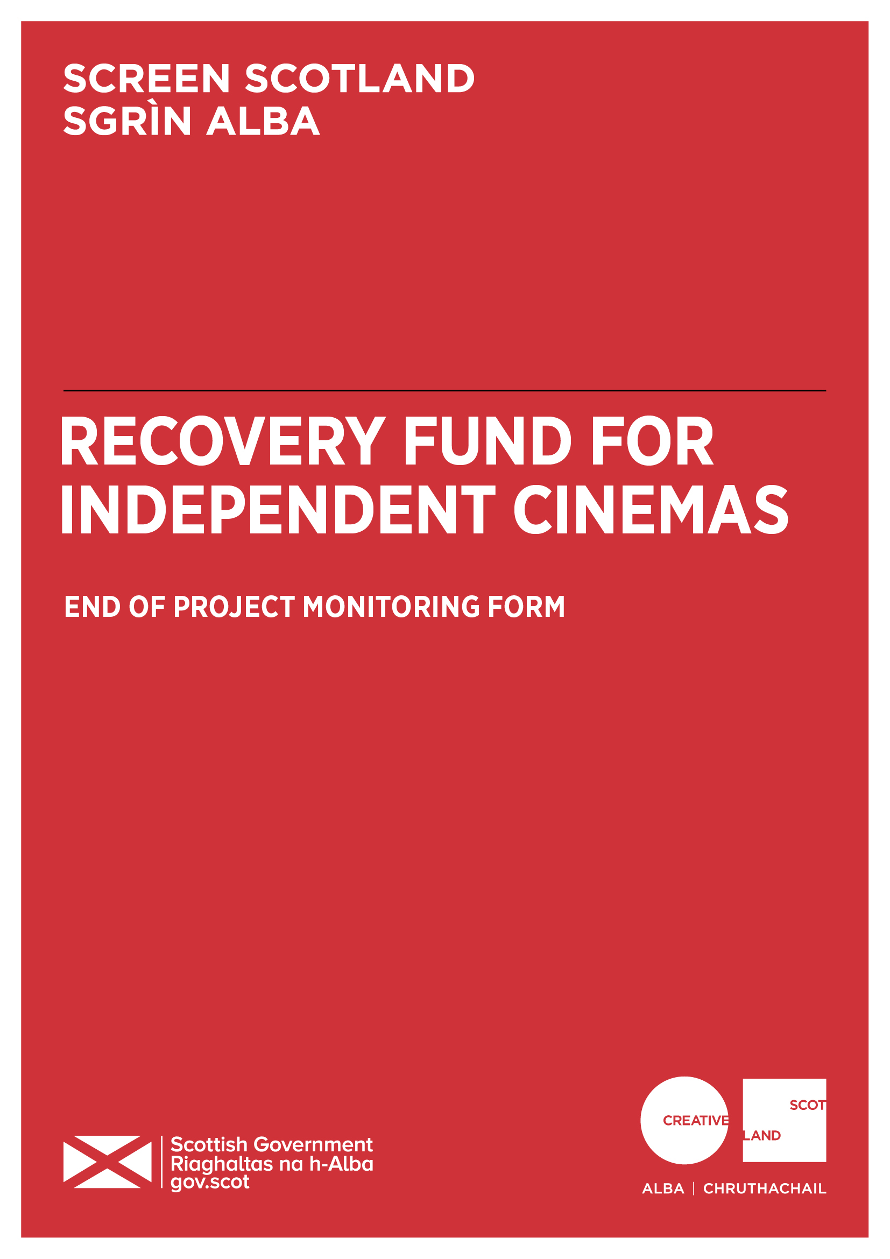

Why do I need to complete this form?

Screen Scotland is leading the growth of the sector through increased funding and support for film and television production, an increase in specialist staff and further investment in skills, festivals, audiences and education. Screen Scotland sits within Creative Scotland and is a partnership with Scottish Enterprise, Highlands and Islands Enterprise, Skills Development Scotland, Scottish Funding Council, with funding from the Scottish Government and the National Lottery.

To demonstrate the impact of our funding, we ask all those in receipt of support to help us – both by providing us with the data we need to show the reach and impact of the creative activity we support; and to tell us about the great work you do. We’re always looking to promote and advocate for the sector by showcasing success stories and case studies.

Completing this form will enable us to process any remaining payments outstanding as per the payment schedule agreed in your original funding agreement. And finally, this form is your chance to tell Screen Scotland how we did. Can we improve our processes, or make our information, guidance, and support better?

When should I complete this form?

We ask that you complete and return this form to us before Tuesday 28th February 2023. When answering the questions, please refer to your original application and the funding agreement you signed. Please note that for accounting and audit purposes, this form, and particularly the Certified Income and Expenditure statement, must be physically signed off by the lead contact for the application to indicate a true and accurate representation of income and expenditure. A scanned/electronic version of this signature is acceptable.

Once completed, you should return this form by email to:
screendeliverables@creativescotland.com

Please note that we prefer this form to be completed and returned by email. However, if you would like to send in a handwritten version, do so using BLACK INK and BLOCK CAPITALS throughout. You can post the form to:

Funding Team,
Creative Scotland,
Waverley Gate,
2-4 Waterloo Place,
Edinburgh, EH1 3EG.

1. Applicant name
2. Your grant reference number
(You will find this on the grant offer letter)
3. Which funding programme did you receive support from? | Recovery Fund for Independent Cinemas
4.1. Please give the start and finish dates for the funded activity*

Income stabilisation:
Start date: | DD/MM/YY | Finish date: | DD/MM/YY

New activity project:
Start date: | DD/MM/YY | Finish date: | DD/MM/YY

4.2. If these were not the dates you originally outlined in your application, please briefly explain the reason for the change and describe the impact the change had on your project, if any.

* All funding must be committed by the 31st of December 2022, although we understand that some activity may take place after this date.
5.1. Tell us how your project went. You applied outlining your planned activity and updated us in May 2022. Has the activity that you delivered or are delivering changed?

Max 200 words.
5.2. What worked well? What challenges did you have and how did you deal with them?

Max 400 words.
5.3. Please tell us how the funded project has reached people and benefited the public?

Max 300 words.

5.4. If known, what percentage of audience members were new visitors and what percentage were return visitors?
% of return visitors
% of new visitors
Unknown

5.5. 1) What have your admission and sales been during the below periods:
We are monitoring the health and recovery of the independent cinema sector in Scotland and using this data to advocate for sector support. Please share what you are able. All information will be held in strictest confidence and only aggregate data across organisations and trends will be shared beyond Screen Scotland.
To enter your figures on the spreadsheet below, please double click on the cell, enter the number, and click anywhere outside of the spreadsheet to stop editing. The figures entered will be automatically calculated in the percentage and total boxes.

5.5. 2) Comment on the above data
Highlight any specific issues challenges faced by your organisation and/or wider industry issues.

Max 200 words.
6.1 How many FTE positions were protected by the funding during the project period?

6.2. How many FTE positions were created by the funding during the project period?

6.3. How many FTE positions protected or created by the funding have you been able to retain since the end of the funding period?

Protected
Created

7.1. Tell us what you think the long-term benefits of the new activity project will be for you or your organisation.

7.2. What were the benefits of the sustainability funding for your organisation?
How has this effected the long-term situation of your organisation? How does it relate to the above answer regarding your current financial position?

What is your current financial position?
8.1. How would you summarise your current financial position? In answering this question, you should consider recent trading performances, your running costs, and cash position.
- Strong
- Good
- Fair
- Poor
- Weak

8.2. Comment on the above financial position

Max 200 words.
8.3. What are your key concerns over the next 6 months?

Of the categories below, which are the major concerns to your organisation over the next 6 months.

 | Area | Level of concern | Optional comment  (max 100 words)
1 | Inflation (excluding energy)
2 | Fuel Costs
3 | COVID-19 returning
4 | Reducing Carbon
5 | Implementing Fair Work
6 | Other |  | Please give details:
Levels of concern
5. extremely concerned
4. very concerned
3. concerned
2. not concerned
1. not applicable

9. Where did your project take place?
Tell us, as clearly as you’re able, the split of there the project happened – including any of the development work, delivery of events, performances, tours, or outreach work.

 | % of delivery | Please specify areas
In your own physical location(s)/venue(s) where applicable
In your Local Authority area
In other Scottish Local Authority areas
In other parts of the UK
International
Online |  | Please specify which platforms you used:

10. Did any of the following groups specifically engage with the project?
We are looking for a yes/no for each group. You don’t need to detail any specific numbers for each but if you have more detailed audience data, we would appreciate you sharing it with us on a separate page.

Audience | Did you intend to engage with this audience?  Y/N | Did you successfully engage with this audience?  Y/N
Black, Asian or Minority Ethnic Groups
Children and Young People
Disabled People
Faith/Religious Groups
Gender Groups
Health/Wellbeing Groups
LGBTQIA+ (Lesbian, Gay, Bisexual, Transgender, Queer, Intersex, Asexual) People
Looked after Children
Older People
Refugees/Asylum Seekers
Gaelic Speakers

Application and funding process

11.1. Did you find the application and funding process clear? | YES/NO

11.2. Referring to your answer above, can you tell us more about how we did?
This can include how we present the information (in guidelines and online), the advice or guidance we give (through emails, speaking to our staff or the enquiries service), the assessment and decision-making process, the payment of funding or any support during delivery of the project.

Signature: | Date:

Important information about the data you submit in this form:
Openness and accountability
Information supplied by you will be held in manual files. It will then be summarised and details transferred to a computer-based grants management system. Reports from the information you supply and from any comments made by external assessors and staff members are likely to be held on both manual and computer-based systems. The information you supply will be made available to those assessing any other grant applications you make.
Data protection
Data held on our grants management system is used for statistical and accounting purposes. We view your signature on your application form as acceptance of the use of your data outlined above.
What happens next?
Once completed, you should return this form by email to: screendeliverables@creativescotland.com
Upon submission, you will get an automated response confirming that we have received the form. This process will generally take 2-4 weeks but can take longer if information is incomplete or needs to be checked.
Alongside this, the form will be shared with Creative Scotland’s Knowledge and Research Team, whose role it is to gather the statistical data we need when we are asked to report on the work we do.
The Communications Team will also be given access to the form, and they may contact you directly if they would like to run a feature or case study on you/your work. To be featured as a case study or to tell us more about your work please email (FAO: Screen’s dedicated Digital Communications Officer) on screen@creativescotland.com
Feedback provided on how Screen Scotland can change or improve our processes will be added to a log of issues we keep for this purpose. This log is discussed regularly by a working group of staff who are continuously looking to improve our funding processes in response to feedback.

