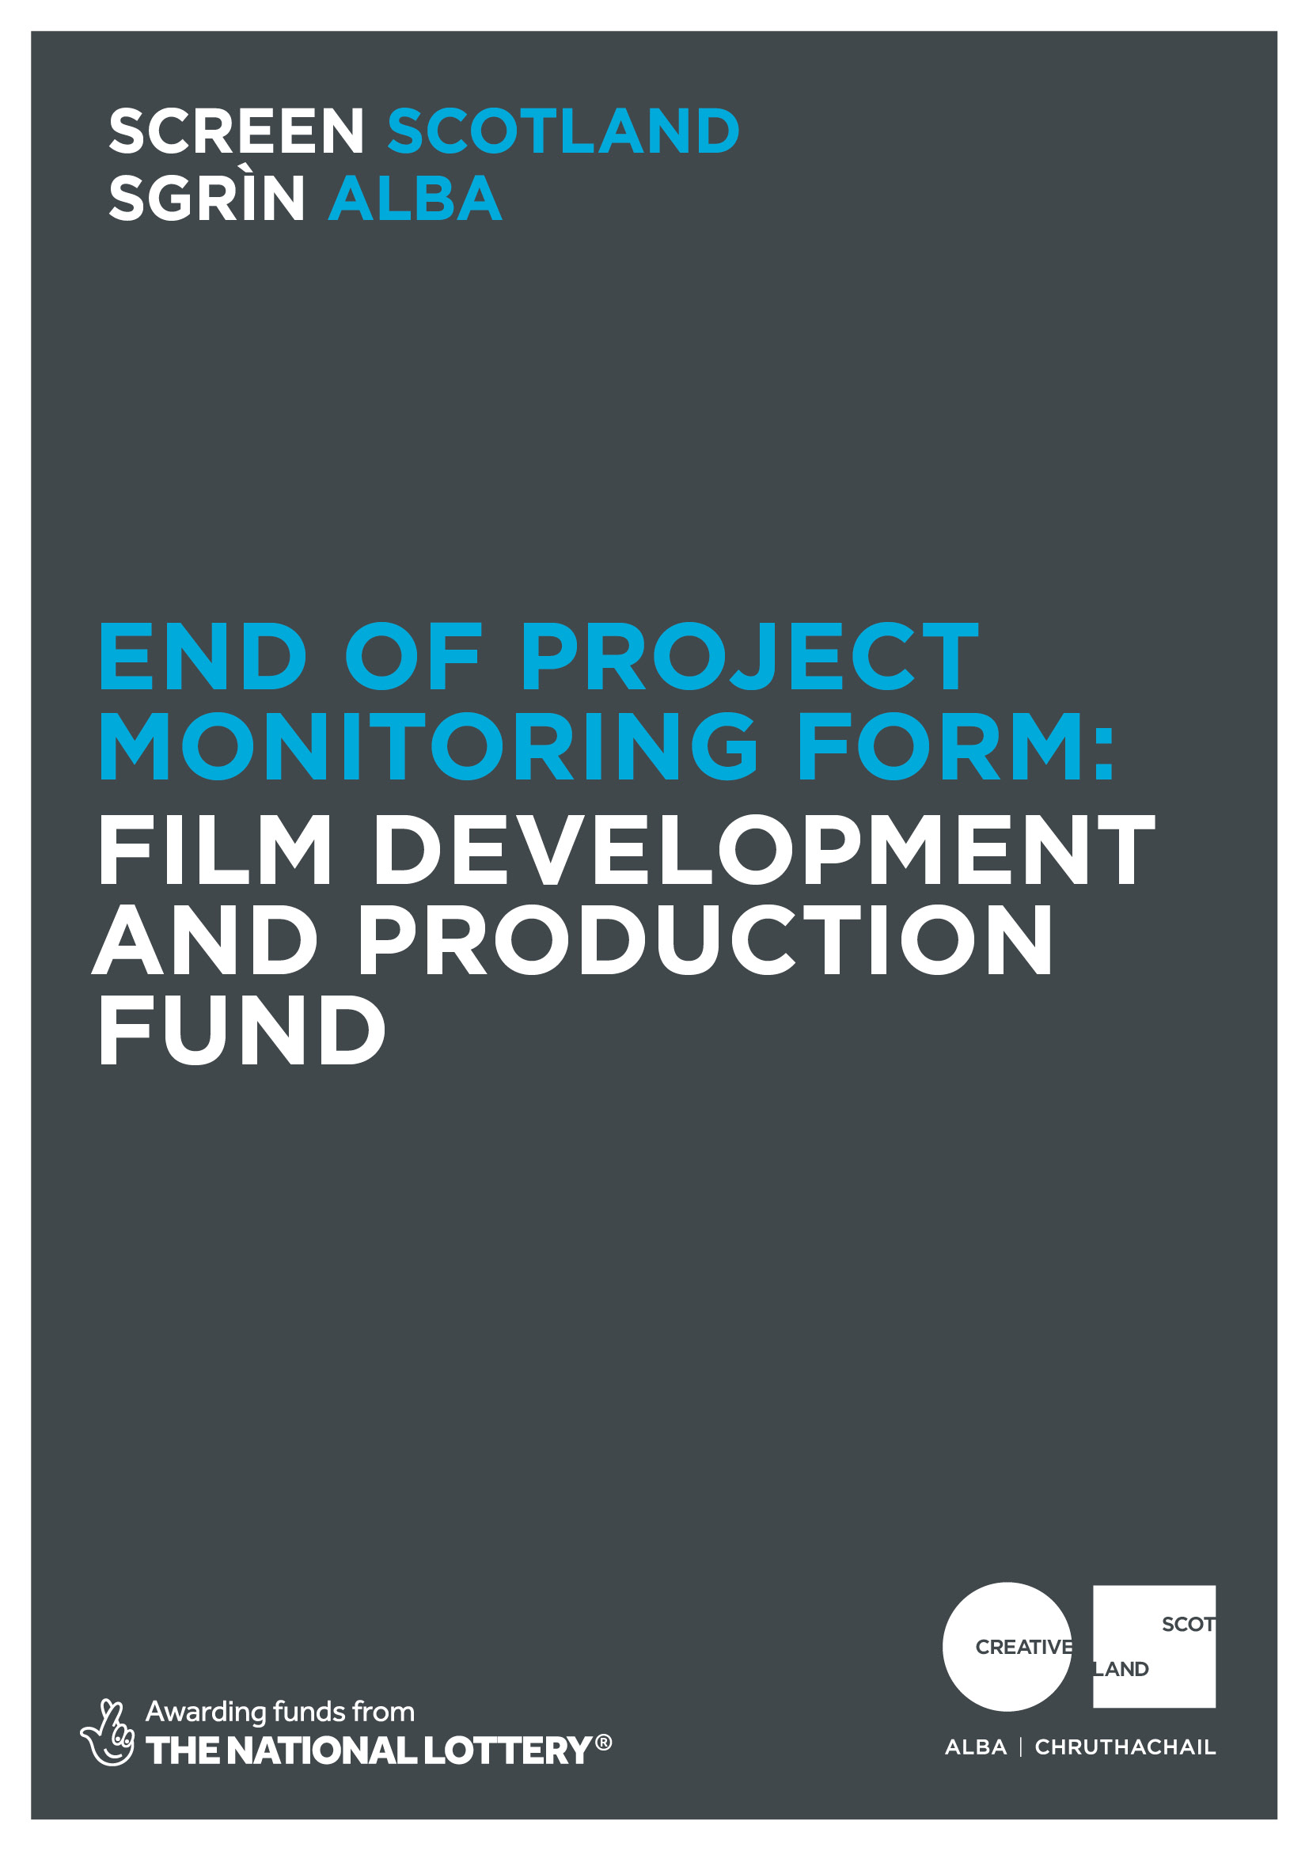

End of project monitoring report
Why do I need to complete this form?
Screen Scotland is leading the growth of the sector through increased funding and support for film and television production, an increase in specialist staff and further investment in skills, festivals, audiences and education. Screen Scotland sits within Creative Scotland and is a partnership with Scottish Enterprise, Highlands and Islands Enterprise, Skills Development Scotland, Scottish Funding Council, with funding from the Scottish Government and the National Lottery.

To demonstrate the impact of our funding, we ask all those in receipt of support to help us – both by providing us with the data we need to show the reach and impact of the creative activity we support; and to tell us about the great work you do. We’re always looking to promote and advocate for the sector by showcasing success stories and case studies. To be featured as a case study or to tell us more about your work please email (FAO: Screen’s dedicated Digital Communications Officer) on screen@creativescotland.com Completing this form will enable us to process any remaining payments outstanding as per the payment schedule agreed in your original funding agreement. And finally, this form is your chance to tell Screen Scotland how we did. Can we improve our processes, or make our information, guidance and support better?

When should I complete this form?
We ask that you complete and return this form to us at the conclusion of your funded activity to release your final payment. When answering the questions, please refer to your original application and the funding agreement you signed. Please note that for accounting and audit purposes, this form, and particularly the Certified Income and Expenditure statement, must be physically signed off by the lead contact for the application to indicate a true and accurate representation of income and expenditure. A scanned/electronic version of this signature is acceptable.

Once completed, you should return this form by email to: screendeliverables@creativescotland.com

What happens next?
Upon submission, you will get an automated response confirming that we have received the form. We will review your form and the Funding Team will then send the form to the relevant screen officer for checking, approval and sign off. Once signed off, this will trigger our Finance Team to issue any outstanding payments. This process will generally take 2-4 weeks but can take longer if information is incomplete or needs to be checked.

Alongside this, the form will be shared with Creative Scotland’s Knowledge and Research Team, whose role it is to gather the statistical data we need when we are asked to report on the work we do. The Communications Team will be given access to the form and they may contact you directly if they would like to run a feature or case study on you / your work. Feedback provided on how Screen Scotland can change or improve our processes will be added to a log of issues we keep for this purpose. This log is discussed regularly by a working group of staff who are continuously looking to improve our funding processes in response to feedback.

- You and your activity
- Applicant name: | - Applicant Company:
- Your grant reference number:  (you will find this on the grant offer letter) | - Which funding route did you apply to? (Please delete as applicable)  - Development Funding  - Production Funding
- Please give the start and finish dates for the funded activity:  Start date: dd/mm/yy Finish date: dd/mm/yy  If these were not the dates you originally outlined in your application, please explain briefly the reason for the change and describe the impact the change had on your project, if any: | - Is/was your film:  (Delete as appropriate)  - Scripted  - Documentary  - Live Action  - Animation  - Other/Mixed  Please Specify: _______
- Tell us how your project went (please continue on a separate sheet if necessary):
- What activities took place and what outputs were achieved as a result of funding? e.g.: how has the project progressed? has it helped the company increase capacity and/or unlocked finance? Were you able to deliver development/production activity of higher quality? if so, in what way?

- What worked well and what challenges did you face as the activity took place? E.g: What were the highlights of your funded activity? How did you overcome any difficulties you faced and what could be done differently next time?

- What do you think the long-term benefits will be?

- For the production company (e.g.: improved development bandwidth, capacity for new hires, potential for enhanced portfolio)?

- For individuals involved (e.g.: professional development, contacts, experience)?

- What are the next steps for your project?
8.1) Development Award Only
At what stage of development is the project now? (Delete as appropriate)
- Proof of concept/taster footage
-Concept art/look book
-Treatment
-1st Draft
-Final Draft
-Other______

Tell us about any further development plans, discussions with co-producers, broadcasters, sales agents, distributors, other finance etc:

8.2) Production Award Only
When did the project wrap shooting? | DD/MM/YYYY
What stage is your project now? (Delete as appropriate)

-Post-Production
-Secured Festival screening. If so, which festival(s) / release date (s):
-Secured Theatrical Release. If so Distributor Name / Territory(ies) / release date(s):
-Secured VOD distribution (including SVOD, TVOD and AVOD); if so, Platform Name / release date:
-Other:

Please include any additional details of distributors/festival selection/awards/VOD platforms relationships developed, sales agents, and wider/international audience potential:

- On-Screen Representation
- Did your project address under-representation of the particular groups below? (either through storyline themes and narrative, and on-screen contributors or cast):
We’re just looking for a Yes / No for each group – you don’t need to detail any specific numbers for each but if you have more detailed data we would appreciate you sharing it with us on the next question.

 | Main storyline/ subject matter  (Y/N) | Other storyline/ subject matter  (Y/N) | Lead Cast/ Characters /Contributors/ Presenters/ Voice Artists  (Y/N) | Other characters / Cast/ contributors/presenters/ voice artists/competitors  (Y/N)
50:50 gender balance
Identify as coming from Black, Asian or Minority Ethnic background within Scotland
LGBTIA+ (Lesbian, Gay, Bisexual, Transgender, Intersex, Asexual) people

D/deaf and Disabled people
Identify as coming from a lower socio-economic background
Looked-after children
Caring responsibilities |  |  | n/a | n/a
Gaelic speakers
Other languages spoken in Scotland (e.g. Scots, BSL, Polish, Urdu)
Refugees / Asylum seekers / Migrant background
Location (s) under-represented geographical areas in Scotland including region, location or community
Older people
Faith / religious groups
Health / wellbeing groups

- If applicable, tell us a bit more about how the project addressed under-representation in the lead and secondary cast, characters, talent or contributors, and/or the main and secondary storylines, themes and narratives and where the project is set. What were the main challenges you faced and how did you overcome them? (please continue on a separate sheet if necessary)

- Others involved in the project /activity (Development Projects only*)
- Tell us how many people based in Scotland were paid, employed or trained/interned as part of your project:
Please include any other practitioners, crew, staff, employees, workers.
*For Production Funding, a ‘list of crew, trainees and interns engaged on the Project, including names, positions held and location’ is part of the Deliverables Schedule requirements and should be submitted separate to this form.

 | Total | How many are based in Scotland?
Employed full time staff
Employed part time or casual staff
Freelance staff
Paid work placements
Unpaid work placements
Paid apprenticeships / traineeships
Unpaid apprenticeships / traineeships
Paid internships
Unpaid internships

- Sustainability (Development and Production Projects)
- Please let us know about any steps you took to mitigate the environmental impact of your project.
If your production received albert sustainable production (wearealbert.org) certification or used their carbon calculator then please give details. If this was a development project, please tell us how you plan to do this as the project goes into production.

- Financial management
- Please provide the following summary information and send a certified financial statement (part of the contracted deliverables). Guidance on allowable Scottish Spend can be found here.

Forecast spend in Scotland | £
Actual spend in Scotland | £

Forecast total project cost | £
Actual total project cost | £

If there were any significant changes (over 10% variation) between actual and forecast figures, please detail these below. If costs increased, please tell us how you managed the shortfall:

- Application and funding process
- Did you find the application and funding process clear? | Yes/No
- Referring to your answer above can you tell us more about how we did?
This can include how we present the information (in guidelines and online), the advice or guidance we give (through emails, speaking to our staff or the enquiry service), the assessment and decision-making process, the payment of funding, or any support during delivery of the project.

- Please provide any other feedback on your funded activity which you consider relevant, or which we have specifically requested as a special condition of funding?
Please refer to your offer letter

- Required Documents Checklist
Please ensure you have also sent the following documents with or by the time of submitting this form:
□ All Delivery materials, as per Creative Scotland signed agreement sent to screendeliverables@creativescotland.com (Production and Development Funding)
□ Complete Crew and Trainees list -Including role and place of residency. Sent to screendeliverables@creativescotland.com (part of Production Funding Deliverables)

Signature: | Date:

Important information about the data you submit in this form:

Openness and accountability
Information supplied by you will be held in manual files. It will then be summarised and details transferred to a computer-based grants management system. Reports from the information you supply and from any comments made by external assessors and staff members are likely to be held on both manual and computer-based systems. The information you supply will be made available to those assessing any other grant applications you make.
Data protection
Data held on our grants management system is used for statistical and accounting purposes. We view your signature on your application form as acceptance of the use of your data outlined above. See our full privacy notice here.

