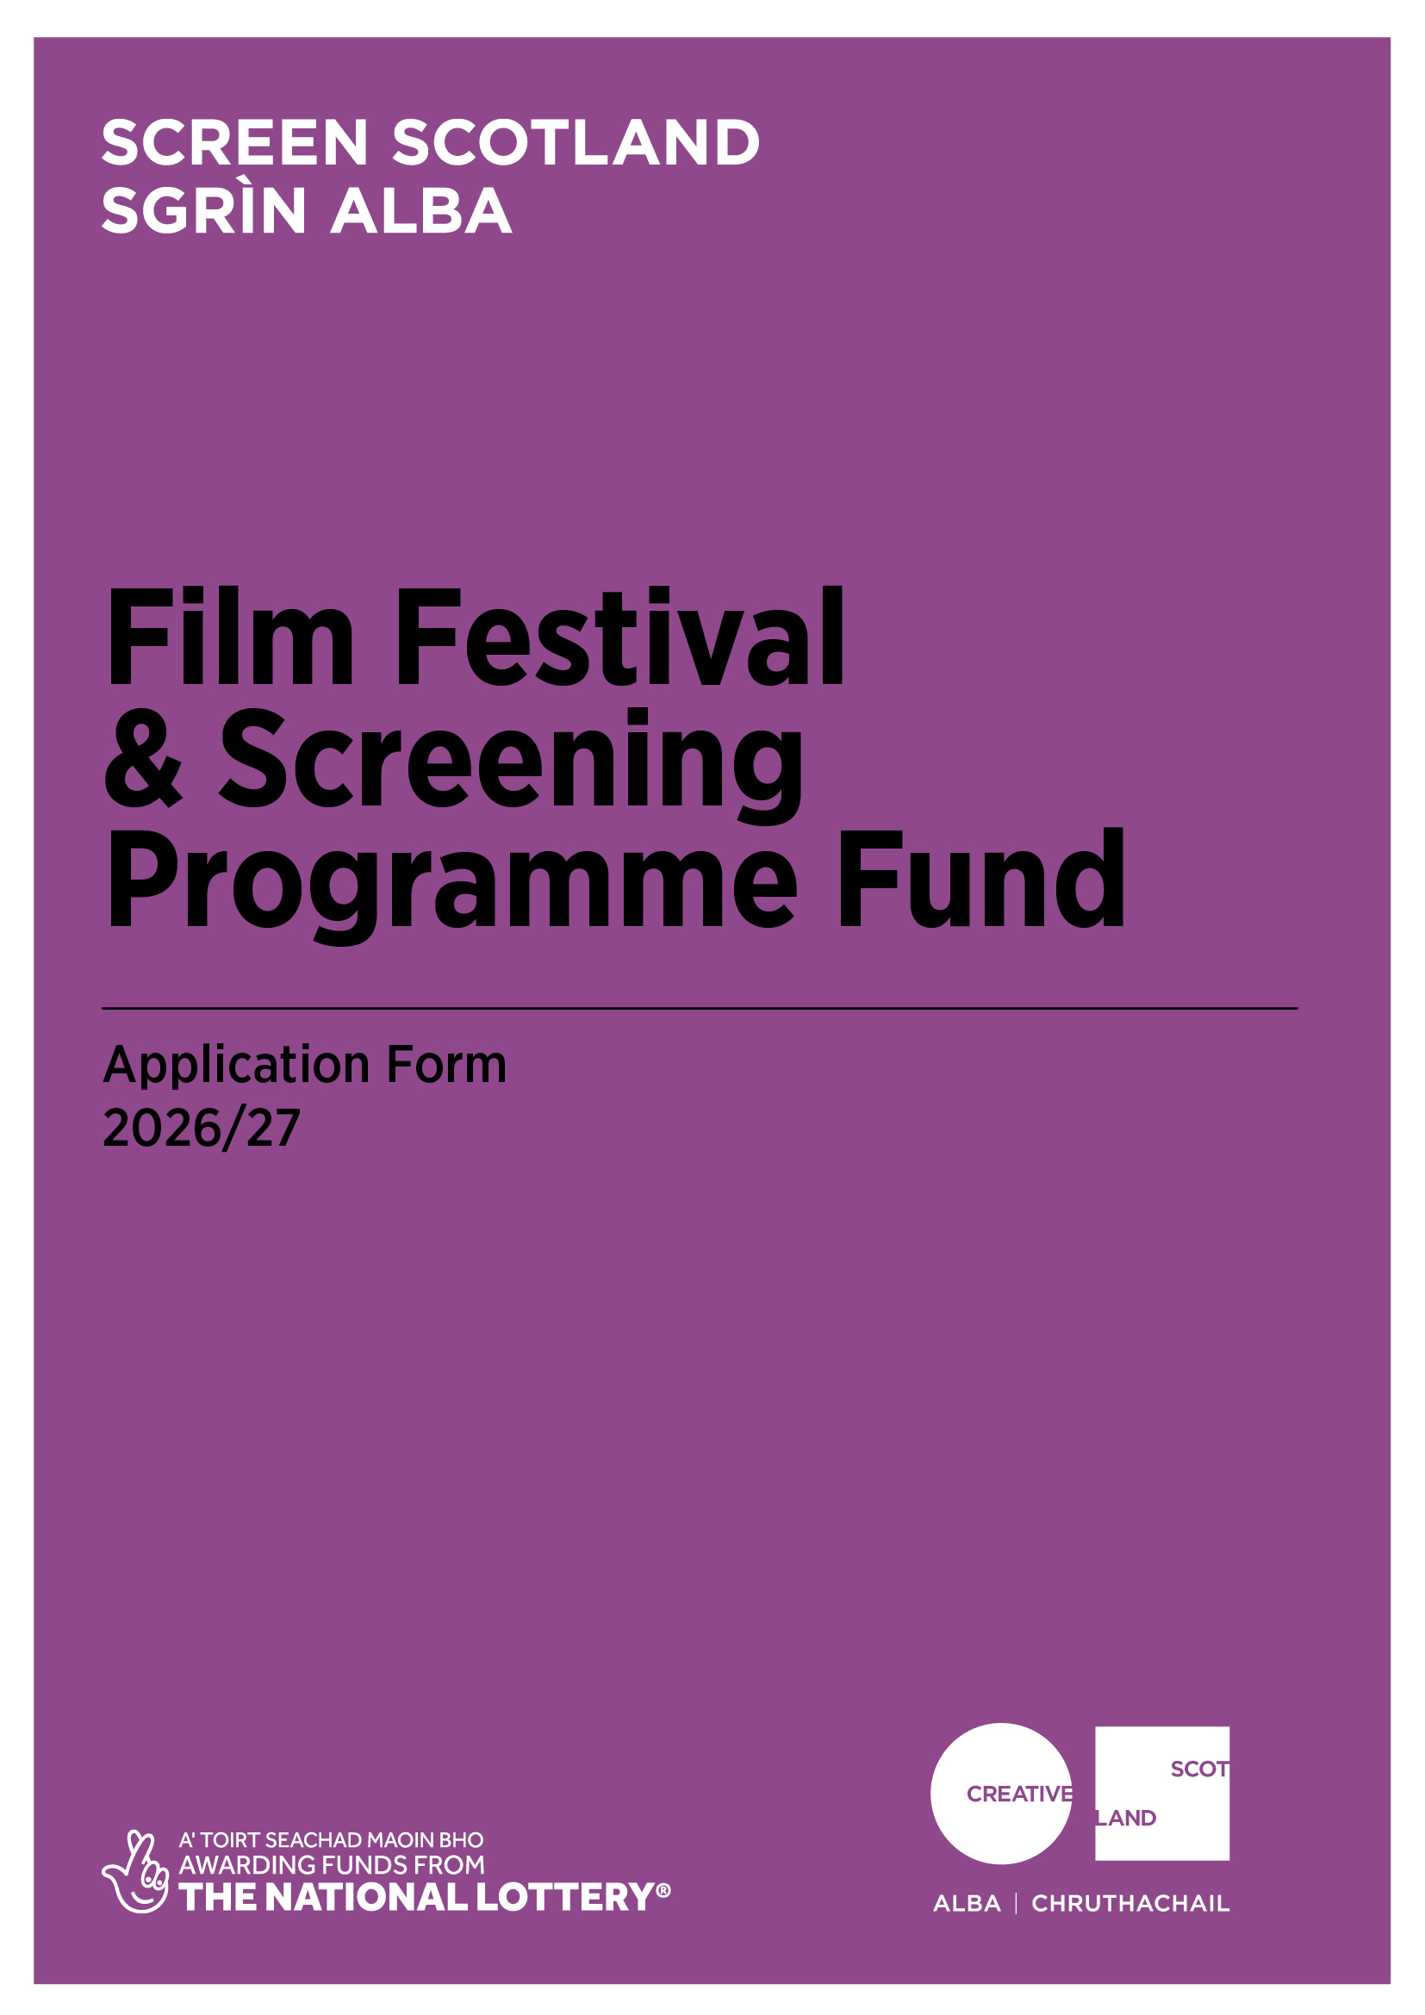

Application Form
Film Festival & Screening Programme Fund

Advice and information
Please read the Film Festival & Screening Programme Fund guidance before making an application.

If you have any general enquiries about the application process, guidelines or application form please contact us.
Alternative Formats and Languages
Our published materials, including funding guidance and application forms, are provided in alternative formats and languages. On request, they can be made available in other formats, as required.
We can accept applications and supporting materials which are written in English, Gaelic or Scots.
Access Support
Access support contributes to costs for services to help applicants overcome barriers to applying for our funds.
We offer access support to individuals or the lead applicant of a group who self-identify as d/Deaf, hard of hearing, disabled or living with chronic illness, mental illness or neurodivergence, such as dyslexia, autism or ADHD.
For information on the types of support available, how to request assistance and how to include access costs in your funding application please visit our website.
If you are a d/Deaf BSL user, you can access our services with the Contact Scotland-BSL programme. Visit www.contactscotland-bsl.org for more information.
Contacting our Enquiries Service
If you require technical support, further information or have any other queries, contact our Enquiries Service by emailing: enquiries@creativescotland.com
BFI Diversity Standards
All applications must meet the Screen Scotland BFI Diversity Standards to be eligible for this fund.
Alongside your application, applicants must evidence that they have made an application to the BFI Diversity Standards (not of passing the standards) prior to applying to us.
For more information, please read the BFI Diversity Standards section of the guidance, and visit our website to learn more.
To begin your application, visit the BFI portal.

Section A: Key Information
Please confirm that you have read the Film Festival and Screening Programme Fund Guidance before completing this application form? | Yes
 | No
Do you object to receiving National Lottery Funding for religious and any other reasons? (Delete as appropriate) | Yes
 | No
Do you hold a UK Bank account in the name of the lead applicant/organisation?  Please note that we will only ask you for your banking details if you’re successfully awarded funding – not before. For audit purposes and compliance, we require all applicants to hold a UK Bank Account. | Yes
 | No

Please confirm that you have read and understood Screen Scotland’s Funding Privacy Notice before completing this application form? | Yes
 | No
Please confirm that you have read and understood Creative Scotland’s Lottery Terms and Conditions before completing this application form? | Yes
 | No

Please confirm that you have submitted your project to the BFI as part of the BFI Diversity Standards - this is an essential requirement for all applicants and your application to Screen Scotland will not progress until you have done this. | Yes
 | No

Section B: Contact Details
All correspondence will be made by email with the named lead contact only - please ensure this information is correct and the lead contact is fully aware of the details in the application.
Please note that organisations are required to provide additional supporting materials, more details can be found on page 22.
All applicants must complete this section
Name of Organisation
Lead Contact Name and Position (if appropriate)
Address
Postcode
Telephone Number
Email Address

Web Address
Key venue address(es)
Key venue website address(es)
Are you a registered company? (Delete as appropriate) |  | Yes
 |  | No
If you are a registered company, please provide your Registered Office address and Company Number
Are you a registered charity? (Delete as appropriate) |  | Yes
 |  | No
If you are a registered charity, please provide your Registration Number

Trading Name of Organisation
Full Legal Name of Organisation (if different from above)
Is your organisation an affiliate of subsidiary of another organisation? |  | Yes
 |  | No
If yes, please provide details
What legal type of organisation are you?  (You should only choose one. Please type an X in the relevant box in the right hand column)  We need the information so we can monitor our decision making and report to Scottish Government and the UK National Lottery on the types of organisations we fund. | Company Limited by Guarantee
 | Company Limited by Shares
 | Scottish Charitable Incorporated Organisation (SCIO)
 | Community Interest Company (CIC)
 | Local Authority
 | Cultural and Leisure Trust
 | Public Sector Agency
 | Trust or Foundation
 | Partnership
 | Yes
Does your organisation have a board? If no, do you have any other oversight or advisory group input? Please detail below. |  | No
 |  | No

Are you VAT registered?  If you answer YES and you are registered for VAT, any figures you provide must not include any VAT that you can claim back. |  | Yes
 |  | No
If you are VAT registered, please provide us with your VAT number

Are you in receipt of Creative Scotland Multi-Year Funding between 1 April 2025 and 31 March 2028?  Recipients of Multi-Year Funding are not eligible to be the lead applicant to this fund. | Yes
 | No

Section C: Organisation Information
Is a primary purpose of your organisation producing a film festival and/or screening programme/s? |  | Yes
 |  | No
If no, please provide details of the primary purpose of your organisation

Please outline your primary purpose and reason for wanting to run a film festival and/or screening programme.

(300 words maximum)
Annual turnover of organisation as per most recent audited accounts or equivalent financial summary: | £
Number of permanent employees and the full-time equivalent (FTE) per role related to this project:

N.B. FTE of 1.0 is equivalent to a full-time employee. FTE of 0.5 is equivalent to half of your organisation’s standard hours.
Number of fixed-term employees, how long their contract is for and FTE hours per role, related to this project
Number of volunteer roles related to this project. Please outline their job titles, how many volunteers you use and for how long:

Section D: Activity Summary
Project Title
Please summarise your project. If you are successful in receiving funding, we may use this information in any publicity we produce about your project (200 words maximum)
What are the dates of your main public activity: | dd/mm/yy - dd/mm/yy
When will the funded project start?  Please note, this date must be before your public activity date noted above, to allow for planning and preparation. | dd/mm/yy
When do you expect your project to end?  This date must be after your public activity end date and can allow for reporting time.  Please note, this activity must be complete by 31 August 2026 (or 2027 if awarded Development Funding). | dd/mm/yy

Where will your project take place?  Please tell us as much information as you can about where your project will take place. We will expect you to fill out at least one of these boxes, but please complete as many as are applicable. | Postcodes:
 | Local Authority areas:
 | Outside Scotland:

What is the total budget of the project/activity? | £
What is the funding you require from Screen Scotland? | £
Percentage of Screen Scotland funding in budget:  Note: You cannot apply for more than 70% of your budget. Established festivals are expected to have a high percentage of co-funding and/or in-kind partnership support. | ____%

Please complete this income table with as much detail as you can provide at the time of application:
Type of Funding | Name of Funder/Source of Income | Cash or In-kind | Conditional or Guaranteed or Pending | Amount of Funding/Income | % of Total Project Cost
EARNED INCOME/OTHER (please add rows as required)
Box Office
Please specify
Please specify
SUBTOTAL
PUBLIC FUNDING
Screen Scotland | Screen Scotland | Cash | Pending
Local Authority
Local Enterprise Companies
Broadcasters
Other Lottery
Own Resources (cash and/or in kind, please specify)
Other
SUBTOTAL
PRIVATE FUNDING
Trusts & Foundations
Companies
Individuals & Fundraising
Own Resources (cash and/or in kind, please specify)
Other (please specify)
SUBTOTAL
TOTAL |  |  |  |  | 100%

Please give the annual number of attendees for your three most recent editions. If you have run less than three editions, complete for each edition. If you have yet to run a festival, please leave blank. |  | Year:  In person:  Online:  Total per year:
Year:
In person:
Online:
Total per year:
Year:
In person:
Online:
Total per year:
Please give the projected attendance number for this year’s activity: |  | In person:  Online:  Total:  (Please specify for 2026/2027 and 2027/2028 if applying for Development Funding)
Please give your reasons for any significant projected changes in attendance:
Section E: Quality & Ambition
Please refer to the Quality & Ambition section in the guidance.

Please outline your overall ambition for your project:
- Outline the purpose and creative vision of your organisation, and the purpose of this activity.
- Describe your aims for the project.

(200 words maximum)
Briefly describe your proposed programme

Please consider:
- Do you have a specific focus, theme or priority this year? Why have you chosen this/these?
- Do you offer anything in addition to film screenings (e.g. talks, Q&AS, panels, entertainment, workshops, etc.)?

Please also submit your programme planning document as part of this application. This should provide more detailed information on your draft programme, including proposed key films and events, and outline how you choose your programme.

(200 words maximum)
What makes your activity unique?

- Is there a gap or audience need in film culture in Scotland/UK/your area that your activity will fill? How do you know there is a need for this?
- Are you aware of other festivals or cultural activities that are similar to yours or serves the same audience? (Think geographically, thematically, audience demographics.) What are they and what do you offer that is different or complementary?
- Is there anything you would like to highlight that is unique or innovative about your activity or the way you work? Are there areas in which you are experimenting or would like support to take risks?

(300 words maximum)
Who is involved in developing and delivering your activity?

- Please outline the experience of your key people, and their roles and responsibilities for planning and delivering your activity. Provide either a short professional biography outlining their experience and/or provide links to CVs, professional websites, LinkedIn profiles or equivalent.
- Which key partners you will be working with and how they will be involved in developing and delivering your activity?
- If you have a board/steering group/advisory group, who is on that and how do they support delivery of your activity (including support and expertise in financial management, and ensuring staff are safe and protected)?

(600 words maximum)
Section F: Engagement
This fund prioritises activities that will successfully engage audiences who are under-represented in screen audiences in Scotland. Please refer to the Engagement section in the guidance, as well as the pages regarding Underrepresented Groups and our Focus Areas.

Who are your target audience(s) and how will you reach them?

Who will be your audience?
- Current/expected main attenders (or main target audience if you have not yet had a festival)
- Secondary attenders or the main group you would like to grow during this project period
- Other attenders that you will engage (please detail any you feel are relevant)

Within your marketing plan please be sure to outline marketing and communications activity you will carry out to reach these audiences (e.g. Any specific PR, print distribution, social and digital, ticket pricing and offers, membership plans, advertising etc)

(1000 words maximum in total)
Overall audience aims/strategy (100 words):

Main attenders:
- Describe this audience group.
- Which elements of your programme are particularly relevant to this audience.
- What is their need for your activity?
- What evidence do you have of this audience’s need or interest in your activity/this type of activity? (this can include your own evaluation data/feedback).
- Does this audience require any specific help with access? If so, what?
- Are they involved in programming, decision making or creating events? If so, how?
- Do you have partnerships with help you connect to this group? If so, who and how?

(350 words maximum)
Secondary attenders:
- Describe this audience group.
- Which elements of your programme are particularly relevant to this audience.
- What is their need for your activity?
- What evidence do you have of this audience’s need or interest in your activity/this type of activity? (this can include your own evaluation data/feedback).
- Does this audience require any specific help with access? If so, what?
- Are they involved in programming, decision making or creating events? If so, how?
- Do you have partnerships with help you connect to this group? If so, who and how?

(350 words maximum)
Other attenders:
- Describe this audience group(s).
- Which elements of your programme are particularly relevant to this audience.
- What is their need for your activity?
- What evidence do you have of this audience’s need or interest in your activity/this type of activity? (this can include your own evaluation data/feedback).
- Does this audience require any specific help with access? If so, what?
- Are they involved in programming, decision making or creating events? If so, how?
- Do you have partnerships with help you connect to this group? If so, who and how?

(200 words maximum)

Impact

How will you measure the impact of your activities?

Please mention what kinds of evaluation techniques you use and what you will measure (e.g. attendance, demographics, feedback). Please note if you have any specific targets or outcomes you wish to achieve.

Please ensure that these relate to your overall sims for the project mentioned above as well as any other aims you have mentioned in the application (e.g. EDI, sustainability).

(400 words maximum)

Section G: Equalities, Diversity & Inclusion (EDI)
Please refer to the Equality, Diversity & Inclusion section in the guidance.

In relation to the overall purpose of your organisation, please outline any information you would like to share about your aims and approach regarding Equalities, Diversity and Inclusion (EDI). If you have already covered this in other sections, please refer to that section. You do not have to repeat the information here.

Please consider:
- What aspects of EDI and accessibility are most relevant to your audiences and achieving your own aims?
- Do you have specific EDI aims for this project?
- Are there any accessibility measures, not already mentioned, that you are putting in place to make your activity accessible and inclusive to a wider audience? (Venue accessibility, number of films/events with Closed Captions, Audio Description, BSL translation, bursaries, location of venues, specially chosen times and dates etc)
- Have you carried out an accessibility audit in relation to your activities and are you planning work related to this? (If not, you can consider applying for funding to support this within your application budget).
- Any training, research, evaluation, consultations, reports, guidelines, or partnerships that have helped you decide how to work with EDI.

Within your marketing plan, please outline how you will make relevant audiences aware of the availability of any accessibility measures.

(400 words maximum)

Section H: Environmental Sustainablity

Please refer to the Environmental Sustainablity section in the guidance.

- Please tell us what steps your organisation is taking to reduce carbon emissions and environmental impact, particularly in relation to delivering this project.
- Will your activity/work with audiences be impacted by the effects of climate change? (e.g. extreme weather) How will you respond to this?
- Please tell us about any aspects of this project which will actively build awareness, share, or investigate measures to address the climate crisis.

(300 words maximum)

Section I: Fair Work

Please refer to the Fair Work section in the guidelines.

Fair Work is a set of principles designed to encourage and support employers to adopt fair work practices within their organisation.

- What commitments have you made, or intend to make, to fair work within your organisation and during this project?
- How is Effective Voice demonstrated within your organisation and this project? (This can include e.g. if staff are part of a union; if you have weekly meetings and/or one-to-ones with the team; if freelancers have a clear point of contact and regular check ins; if you gather programming suggestions in some way, etc)
- Please describe your approach to fair pay, industry rates, or how you work with volunteers?

(300 words maximum)
Please note, if you are successful, you will be required to complete a Fair Work pro forma. This will be sent to you at the contracting stage.

Section J: International - Optional Section
Please refer to the International section in the guidelines.

Please describe your International work. This does not cover programming international films or bringing guests to your festival (please describe that activity in the Programme section above or Programme planning document).

- Please outline ways in which you are strengthening international collaboration and promoting cultural exchange. Please outline the international partners and activity that form part of this work.
- What will the impact be for you and your partners, the Scottish film industry and/or your audience?
- How does your approach to international working relate to your commitments to environmental sustainability?

(300 words maximum)

Section 2: Development Funding – two-year funding support (optional)
In 2026, Screen Scotland is offering an opportunity for applicants to request additional funding for activity taking place up to 31 August 2028.

This should cover two editions of a festival and/or up to two years screening programme activity. This will be considered in addition to your application for activity up to 31 August 2027.

Funding is limited and it is anticipated that 3-5 festivals will be able to be prioritised for this additional support. We understand that not all projects will meet the below criteria, and you are under no obligation to apply for this extended support.

Only complete this section if you wish to be assessed for Development Funding.

Section 2A: Eligibility Criteria

Please outline how you meet the Eligibility Criteria as set out in the Film Festival & Screen Programme Guidelines.

(800 words maximum)

Section 2B: Two-year Development Goals

Please outline which of the key areas of developments listed below Extended Funding would enable your film festival to undertake, and what the need is for two-year support:
- Fundraising, revenue generation and financial responsibility
- Organisation sustainability and development
- Talent development
- International collaboration and activity
- Increasing access and participation
- Ensuring diversity and inclusion
- Providing stability for staff, including at management and board level

(800 words maximum)

Section K: Supporting Materials
In this section we have listed the essential and optional information that you will need to supply in support of your application. Please do not send any other information as this will not be considered within the assessment process.
Supporting material | Essential | Optional | Tell us if this information has been attached to the application or where it can be accessed
Confirmation of submission of BFI Diversity Standards Scotland | x
A document outlining your programming strategy and draft programme | x
Your company/organisation documents – i.e. Memorandum and/or Articles of Association | x
Your Equal Opportunities Policy. If you have an Equalities, Diversity and Inclusion Action Plan, please submit this too | x
Marketing and PR plan | x
Risk Assessment, using the template provided on the fund’s webpage | x
Example brochure or published programmes from previous events |  | x
Letters of Intent from partners |  | x
Equalities monitoring form* |  | x
Financing Plan and Budget** | x
* Equalities monitoring form
We strongly encourage you to complete this to help us monitor our progress, or otherwise, in this area. If you send this to screen@creativescotland.com it will be treated confidentially.

** Please read the Budget section of the Guidelines before submitting this.

Statement of Acceptance
PLEASE STATE THE NAME OF THE PERSON WHO HAS COMPLETED THE FORM. THIS PERSON MUST BE AN AUTHORISED SIGNATORY OF THE ORGANISATION APPLYING, OR BE THE PERSON NAMED IN SECTION A OF THE CONTACT DETAILS.
I hereby confirm that the information in this application submission including the supporting documents is true and correct and I acknowledge that it is my responsibility to inform you immediately of any changes which could affect the interpretation or context of the application, and I confirm I will undertake to do this.
I acknowledge that the terms and conditions of this application and any other information supplied and discussed regarding this application, the assessment and decision making process, or in connection with this transaction as a whole (“the Confidential Information”) is and shall remain strictly confidential. I confirm that I shall not disclose to any third party or make public the Confidential Information without Creative Scotland’s prior written approval.
I acknowledge that Creative Scotland will endeavour to keep all information provided securely, but as a Public Authority in terms of the Freedom of Information (Scotland) Act 2002, may be required to disclose certain information under the Act. Where I stipulate at the time of providing information to Creative Scotland that I believe the information should be considered exempt from disclosure under that Act, and a request to Creative Scotland is subsequently made for disclosure of same or all of that information, Creative Scotland will endeavour to discuss such disclosure with me prior to making its decision. I do, however, accept and acknowledge that the ultimate decision on disclosure rests solely with Creative Scotland regardless of any prior statements or requests I have issued.
I confirm that all cash and in-kind contributions from the company or my own personal resources stated in the funding plan section of this application form are correct and that I have the authorisation to allocate the sums stated and I am responsible for ensuring that adequate resources will remain available to meet these requirements. In the event of any changes to the sums indicated I will provide a signed letter of confirmation.
I acknowledge that Creative Scotland is obliged to comply with Money Laundering Regulations 2007 and the Proceeds of Crime Act 2002 and I will, if requested, provide ID verification from any investor or myself, where appropriate, to meet compliance requirements.
I acknowledge that once Creative Scotland have confirmed the Offer of Funding in writing (via email) that Creative Scotland have the right to publicise their Offer of Funding on the Creative Scotland website and through other Creative Scotland information channels. I understand that Creative Scotland’s Offer of Funding does not place Creative Scotland under any obligation to release funds until such time as all contractual negotiations are complete and Creative Scotland’s Conditions Precedent have been met and their Funding Agreements signed off.
I confirm that I will not make any public statements (or allow others to do so on my behalf) regarding Creative Scotland’s Offer of Funding until such time as Creative Scotland has authorised and approved the form and content of any public statement.
I confirm that I have the power to accept the award under the conditions set out in the Creative Scotland Guidelines and in this Application Form.
I declare that I have read and understood the Creative Scotland Guidelines, this Application Form, Funding Privacy Notice and the Conditions of Funding of Creative Scotland.

I hereby confirm acceptance of the above Statement of Acceptance and all related documents.
(PLEASE TICK THIS BOX TO CONFIRM ACCEPTANCE)

……………………………………………
Name of Authorised Person

……………………………………………
Position of Authorised Person

……………………………………………
Date

Please submit your completed application form to

screen@creativescotland.com

Please now complete your Equalities Monitoring Form and email it along with your application form. Please note, the Equalities Monitoring Form is anonymous and will be processed separately from your application.

