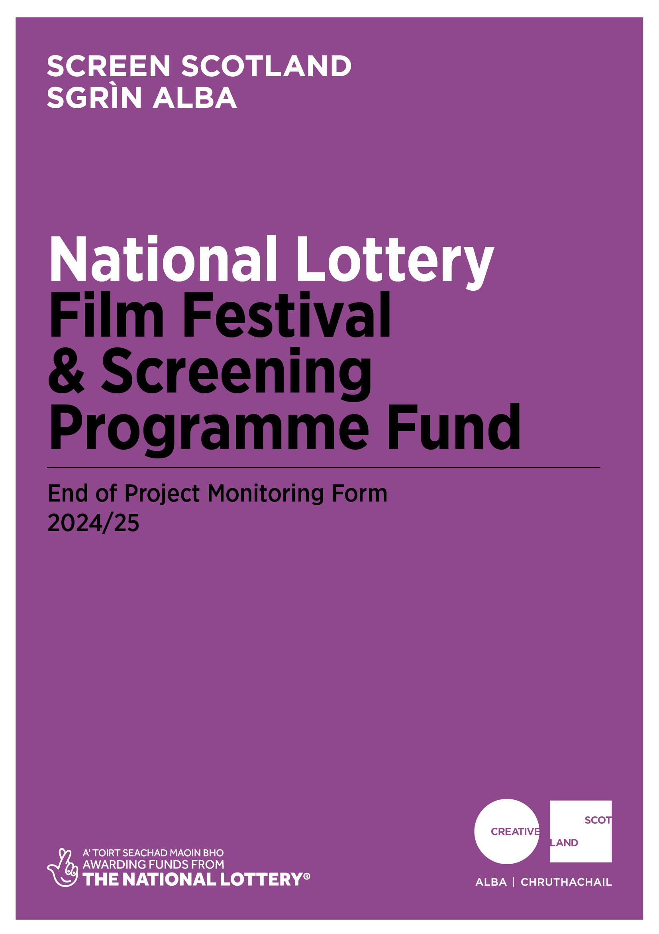
End of Project Monitoring Form
Film Festival & Screening Programme Fund

Why do I need to complete this form?

Screen Scotland drives development of all aspects of Scotland's film and TV industry, through funding and strategic support.

Screen Scotland is part of Creative Scotland and delivers these services and support with funding from Scottish Government and The National Lottery.
Your completion of this form enables us to process any remaining payments outstanding. These will be detailed in the payment schedule agreed in your funding agreement.
It is also your opportunity to give us feedback on how you found the funding process. Can we improve our processes? Can we make our information, guidance, and support better? If so, please tell us.
Finally, the data you provide in this form helps us to show the reach and impact of the creative activity we support through our funding.
We ask all those in receipt of support to help us by providing this data, so we can demonstrate the positive benefits of funding and the reach and impact of the creative activity we support.

Completing this form is an opportunity for you to tell us about the great work you to. We are always looking for new content for Our Creative Voice, to showcase on our website and to share across our social media platforms. If you’d like to get in touch with our Communications team, please see our guide to accreditation and promotion.

You can access Creative Scotland’s Privacy Notice which provides details of how it handles and uses personal data.

When should I complete this form?

You should complete and return this form at the conclusion of your funded activity. When answering the questions, please refer to your original application and the funding agreement you signed.

For accounting and audit purposes, this form, and particularly the Certified Income and Expenditure statement (Appendix 1), must be physically signed off by the lead contact for the application to indicate a true and accurate representation of income and expenditure. A scanned/electronic version of this signature is acceptable.

Once completed, you should return this form by email to:
screen@creativescotland.com

Please note that we prefer this form to be completed and returned by email. If you would prefer to send in a handwritten version, please do so using BLACK INK and BLOCK CAPITALS throughout.

What happens next?

Upon receipt, you’ll get an automated response confirming that we have received the form. We’ll review for completeness and the Funding Team will then send the form to the relevant team or officer for checking, approval and sign off.

Once signed off, this will prompt our Finance Team to issue any outstanding payments. This process will generally take 2-4 weeks but can take longer if information is incomplete or needs to be checked.

Alongside this, the form will be shared with our Knowledge and Research Team. It is their role to gather the statistical data we need when we are asked to report on the work we do.

Finally, any feedback provided about how we can change or improve our processes will be added to a log of issues we keep for this purpose. This log is discussed regularly by a working group of Creative Scotland staff who are continuously looking to improve our funding processes in response to feedback.

End of Project Monitoring Form

- You and your activity
- Applicant name: | - Your grant reference number:  (you will find this on the grant offer letter)
- Which funding programme did you receive support from? | Film Festival & Screening Programme Fund
- Please give the start and finish dates for the funded activity*:

Start date: | dd/mm/yy | Finish date: | dd/mm/yy

*If your festival took place online, please let us know what dates was content available from/to.

If these were not the dates you originally outlined in your application, please briefly explain the reason for the change and describe the impact the change had on your project, if any:

- Tell us how your project went:
Please refer back to your funding application and the aims of the activity you were funded to do. Tell us what worked well and any challenges you faced (and how you dealt with them).

- Tell us what you think the long-term benefits of this project will be for you or your organisation?
- Where did your project take place?
Tell us, as clearly as you’re able, the split of where the project happened – including any of the developmental work, delivery of events, performances, tours or outreach work. The below is a summary of where your work took place and a full account of the postcodes of locations is requested in Appendix 2.
 | % of delivery | Please specify areas
In your own physical location(s)/venue(s) where applicable
In your Local Authority area
In other Scottish Local Authority areas
In other parts of the UK
International
Online |  | Please specify which platforms you used:

- Did any of the following groups specifically engage with the project?
We’re just looking for a yes/no for each group – you don’t need to detail any specific numbers for each but if you have more detailed audience data, we would appreciate you sharing it with us on a separate page. For more detailed audience data and accessible screenings offered we would appreciate you sharing it with us on Appendix 3.
AUDIENCE | Did you intend to engage with this audience?  Y/N | Did you successfully engage with this audience?  Y/N
Black, Asian or minority ethnic groups

Children and Young People

Disabled people

Faith/religious groups

Gender Group

Health/wellbeing groups
LGBTQIA+ (Lesbian, Gay, Bisexual, Transgender, Queer, Intersex, Asexual) people

Looked after children

Older people

Refugees/Asylum seekers
Gaelic Speakers

- Please specify where the films you showed were from geographically:

 | % of programme | Please specify areas if possible
Scotland
Rest of UK
Rest of the world

- Others involved in the project/activity
- Tell us how many people were paid or employed as part of your project?
Please include any other artists, collaborators, staff, employees, workers.

- How many people were involved in the funded activity as part of any of the following employment initiatives?

Paid work placements
Unpaid work placements
Paid apprenticeships/traineeships
Unpaid apprenticeships/traineeships
Paid internships
Unpaid internships

- Not including anyone listed in answer to Q.11, how many volunteers were involved in the funded activity?
- In total, how many hours were contributed by volunteers?

- Reaching people
- Please tell us how the funded project has reached people and benefited the public and/or the wider sector?
Questions 14-17 will allow you to give us some of the specific numbers so in this question we’re looking for you to tell us how the reach of the project compares to what you anticipated when you applied. Please refer to your original application and highlight any unanticipated outcomes. In Appendix 3 you can also share details of any accessible activities that may have taken place.

(Continue on a separate page if necessary.)

- Please tell us about public events delivered as part of the funded activity.
If any or all of your funding was specifically to tour your film festival or screening programme, please complete Appendix 2.

 | In Person | Online | Was this actual or estimate?  (delete as appropriate)
Numbers of screenings |  |  | Actual/estimate
Number of admissions/online views |  |  | Actual/estimate
Ticket sales (£) |  |  | Actual/estimate
Number of events |  |  | Actual/estimate
Number of participants |  |  | Actual/estimate
Number of attendances/online views |  |  | Actual/estimate
Ticket sales (£) |  |  | Actual/estimate

Please note:
- Admissions indicate those who attend as an audience member; Participants are those actively learning, being trained or taking part in the activity.

- Please tell us about any learning and outreach sessions delivered as part of funded activity (number of sessions and number of participants):

 | Nursery, school, college or university groups |  | Other |  | Was this actual or estimate?  (delete as appropriate)
 | Online | In Person | Online | In Person
Number of sessions |  |  |  |  | Actual/estimate
Number of early year participants (0-4 years) |  |  |  |  | Actual/estimate
Number of children  (5-17 years old) |  |  |  |  | Actual/estimate
Number of young people participants (18-25 years old) |  |  |  |  | Actual/estimate
Adult learners (26+ years old) |  |  |  |  | Actual/estimate
Other participants (please specify) |  |  |  |  | Actual/estimate
Total number of participants |  |  |  |  | Actual/estimate

* Where you have delivered a programme of learning and outreach activity delivered, please count each session within the programme (a session can be a screening, workshop, talk or other). Individual participants should only be counted once, whether attending a one-off activity or a programme of activity over a number of weeks.

- Please tell us about the number of sessions supporting professional development:

 | In person | Online | Was this actual or estimate?  (delete as appropriate)
Number of professional development sessions |  |  | Actual/estimate
Total number of participants |  |  | Actual/estimate

- Financial management
- Please provide the following summary budget information and send a certified financial statement using the attached form (see Appendix 1).

Forecast total project cost | £
Actual total project cost | £

If there were any significant changes (over 10% variation) between actual and forecast figures, please detail these below. If costs increased, please tell us how you managed the shortfall:

- If partnership funding was pending at the time we awarded your funding, please tell us if you achieved it as hoped and from where. If not fully achieved, please tell us how you managed the shortfall?
Please note: when the final amount of your grant is calculated, if the project has achieved a surplus of funds because costs have reduced or income from other sources has increased, we may reduce our final payment or ask you to repay any overpaid sums as appropriate.
- Please provide any other feedback on your funded activity which you consider relevant, or which we have specifically requested as a special condition of funding? Please refer to your offer letter.

- Application and funding process
- Did you find the application and funding process clear? |  | Yes/No
- Referring to your answer above can you tell us more about how we did?
Give us your feedback on our processes and management, telling us what we do right, and what we can do better - so that we can try to improve how we do things in future. This can include how we present the information (in guidelines and online), the advice or guidance we give (through emails, speaking to our staff or the enquiries service), the assessment and decision-making process, the payment of funding, or any support during delivery of the project.

Signature: | Date:

Certified income and expenditure statement APPENDIX 1

Name of applicant: Grant reference:

Please include all income and expenditure, both cash and in-kind, using the headings given in your application form and in the same order. Where headings include a number of different types of expenditure, you should provide a breakdown showing how the figure has been arrived at. Please provide explanations of any significant variations between budget and actual (greater than 10%) in question 19 in the end of project monitoring report. If you need to use additional pages, please include the grant reference number on each page.

Income |  |  | Expenditure
Source | Budget (£) | Actual (£) | Item | Budget (£) | Actual (£)
Total |  |  | Total
Total surplus / deficit on the project (actual income less actual expenditure): £

Signed: Date:

Printed name: Position (if signing on behalf on an organisation):

Where did your project take place? APPENDIX 2

Please give details of all locations in which activities took place.

Postcode of venue/ Online Platform URL | Date of activities (dd/mm/yy) | Title of event | Name of venue/ Name of Online platform | Number of screenings | Total admissions at in person screenings / Number of views/requests online | Number of events | Total admissions at events | Actual or estimate?

Tell us about your accessible activities APPENDIX 3

Please give details of all locations/online platforms in which activities took place.

Accessibility measure: | Postcode of location of activity/ Online Platform | Title of activity | Number of screenings  (online and in person) | Total admissions/views at screenings  (online and in person) | Number of events  (online and in person) | Total admissions at events  (online and in person) | Actual or estimate?
BSL Interpretation
Captioning
Audio Description
Autism Friendly
Dementia Friendly
Free Ticket Options
Reduced Ticket Options
Child or baby friendly
Creche Option

Important information about the data you submit in this form

Openness and Accountability

Information supplied by you will be held in manual files. It will then be summarised, and details transferred to a computer-based grants management system. Reports from the information you supply and from any comments made by external assessors and staff members are likely to be held on both manual and computer-based systems. The information you supply will be made available to those assessing any other grant applications you make.

Data Protection

Data held on our grants management system is used for statistical and accounting purposes. We view your signature on your application form as acceptance of the use of your data outlined above.

You can access Creative Scotland’s Privacy Notice which provides details of how it handles and uses personal data.

