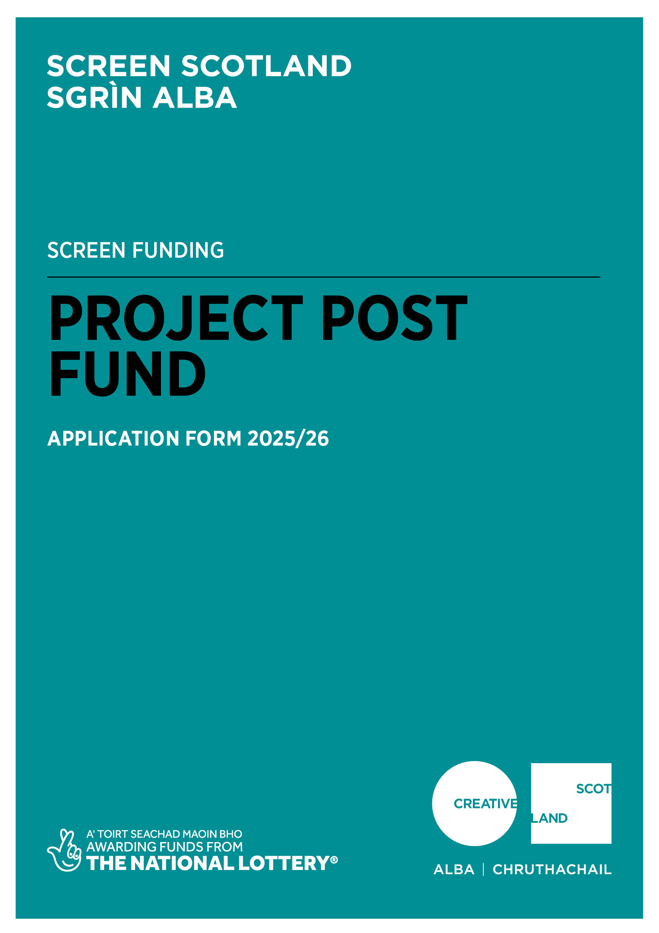

Application Form
Project Post Fund
Advice and Information
Please read the Project Post Fund Guidance before making an application.
If you have any general enquiries about the application process, guidelines or application form please contact us.
Alternative Formats and Languages
Our published materials, including funding guidance and application forms, are provided in alternative formats and languages. On request, they can be made available in other formats, as required.
We can accept applications and supporting materials which are written in English, Gaelic or Scots.
Access Support
Access support contributes to costs for services to help applicants overcome barriers to applying for our funds.
We offer access support to individuals or the lead applicant of a group who self-identify as d/Deaf, hard of hearing, disabled or living with chronic illness, mental illness or neurodivergence, such as dyslexia, autism or ADHD.
For information on the types of support available, how to request assistance and how to include access costs in your funding application, please visit our website.
If you are a d/Deaf BSL user, you can access our services with the Contact Scotland-BSL programme. Visit www.contactscotland-bsl.org for more information.
Contacting our Enquiries Service
If you require technical support, further information or have any other queries, contact our Enquiries Service by emailing: enquiries@creativescotland.com

Application Questions
In order for us to be able to process your application, you need to complete Sections A-E and the Statement of Acceptance in this application form.
Please be advised, we will not be able to process your application if you do not answer all the questions.
Section A: Key Information
Please confirm that you read the Project Post Fund Guidelines before completing this application form. (Delete as appropriate) | Yes
 | No
Please confirm that you have read and understood Creative Scotland’s Funding Privacy Notice and any relevant information sheets before completing this application form. (Delete as appropriate) | Yes
 | No
Have you spoken to a member of Screen Scotland staff about your application before applying? (Delete as appropriate) | Yes
 | No
Section B: Contact Information
Name of Applicant Company
Lead Contact Name and Position
Address
Postcode
Telephone Number
Email Address
Web Address
What type of organisation are you?  Please type an X in the box in the right-hand column. You must be one of these to apply.  We also need the information to monitor our decision making and report to Scottish Government on the types of organisations we fund. | Company Limited by Guarantee
 | Company Limited by Shares
 | Other (please specify)
Are you a UK registered company?  (Delete as appropriate) | Yes
Are you a UK registered company?  (Delete as appropriate) | No
If you are a registered company, please provide your Registered Office address and Company Number.
Section C: Project Summary
Project Title
Please summarise your project or activity.
(200 words)
Type of content  Please type an X in the box in the right-hand column. |  | Live Action Feature Film
 |  | Animated Feature Film
 |  | Live Action TV Drama Series
 |  | Animated TV Series
 |  | Factual Returnable Series
When does the post-production activity start?  (Please note, you must apply at least 12 weeks before your anticipated first day of post-production in Scotland.) |  | Post-production commencement date:
 |  | Anticipated Post-production commencement date in Scotland:
When do you expect the project to end?

Section D: Project Post Fund Request
Please confirm acceptance that a successful award will be paid retrospectively after costs have been incurred  (Delete as appropriate) | Yes
 | No
What is the total post-production budget of the entire project? | £
How much are you requesting from the Project Post Fund?  (Please note, you can apply for any amount between £25,000 and £100,000) | £
What percentage of the project’s post-production total budget does the request represent?  I.e. Project Post Funding / Total Post-Production Budget | %
How much committed co-funding is confirmed?  (Please note, evidence of committed co-funding will be required as supporting documents.) | £
What is the Estimated Scottish Spend budget which relates directly to post-production activity only?  (Refer to Appendix C in the fund guidance, for more information.) | £
What is the Estimated Scottish Spend to funding requested ratio?  (Please note, this should be no less than 5:1, for example, if you are applying for £100,000, your project must have a minimum Scottish Spend of £500,000 (excluding VAT). | :

Provide a short biography detailing any relevant experience or credits you have in film and/or television and provide details of any completed projects.
Place of benefit
Please detail, as required below, the area(s) which will benefit from the production activity in Scotland.
Provide the name and address of the Scotland based facility/ facilities that will be carrying out the post-production work and the key contact details at each facility.  If you are using multiple Scottish facilities, please estimate how much of the Estimated Scottish spend will happen in each facility.  E.g. if only a picture post facility is being used it would be receiving 100% of the Estimated Scottish Spend.  If you are using more than one facility, the total across all facilities should equal 100% of the Estimated Scottish Spend. | Picture Post Facility  Key contact:  % of estimated Scottish spend:
Sound Post Facility

Key contact:
% of estimated Scottish spend:
VFX Facility

Key contact:
% of estimated Scottish spend:
Music Facility

Key contact:
% of estimated Scottish spend:
Animation Facility

Key contact:
% of estimated Scottish spend:
Other Facility

Key contact:
% of estimated Scottish spend:
Provide the name(s) and place of residence of any key Scotland based post-production personnel participating in the project.
Name of the Post-Production Supervisor and/or Producer and place of residence. Please note, they do not have to be Scotland based to qualify for the award.

Section E: Supporting Information - Strategic Priorities
Please provide information on the following Strategic Priorities within the table below and confirm if you have submitted supporting documentation on these
Supporting Information
Environmental Sustainability Plan
Outline how you and the facilities you are working with are responding and adapting to the net zero challenge (max 300 words).

Please refer to the Environmental Sustainability Strategic Priority section of the fund guidance for more information.
Fair Work
Please confirm your activity will comply with Scottish Government’s Fair Work First Policy by checking the boxes below and provide any further, relevant information (max 300 words).

Please refer to the Fair Work Strategic Priority section of the fund guidance for more information.
☐Payment of at least the Real Living Wage to all personnel
☐Inclusive hiring process
☐No exploitative contracts
☐Support career development
☐Effective voice – channels for workers to communicate concerns

Further information:

International
Detail how this activity will strengthen Scotland’s presence in the global screen industry and develop post production expertise (max 300 words).

Please refer to the International Strategic Priority section of the fund guidance for more information.
Section F: Supporting Materials
Please submit the following Supporting Materials with your application form and confirm that each document has been submitted within the table below.
Please note that the failure to provide any required supporting material may result in delays within the assessment process.
Essential Supporting Documentation | Advise if the material is attached to the application or where we can access.
All applicant companies with 10 or more employees, must provide an Equalities and Diversity policy, or Equal Opportunities Policy. If you have an Equalities Plan, please submit this also.
A copy of founding legal documents (e.g. Articles of Association, Trust Deeds, or written constitution)
Full, detailed post-production budget
Post-Production Schedule
Finance Plan, including evidence of all committed finance
Estimated Scottish Spend Budget
(including quotes from Scotland based facilities)
Optional: Applicants are encouraged to include a plan outlining inclusive training and crew development opportunities - see guidance in Appendix A of the Project Post Fund Guidelines.

Statement of Acceptance
Please state the name of the person who has completed the form. This person must be an authorised signatory of the company or organisation applying.
I hereby confirm that the information in this application submission including the supporting documents is true and correct and I acknowledge that it is my responsibility to inform you immediately of any changes which could affect the interpretation or context of the application, and I confirm I will undertake to do this.
I acknowledge that the terms and conditions of this application and any other information supplied and discussed regarding this application, the assessment and decision-making process, or in connection with this transaction as a whole (“the Confidential Information”) is and shall remain strictly confidential. I confirm that I shall not disclose to any third party or make public the Confidential Information without Creative Scotland’s prior written approval.
I acknowledge that Creative Scotland will endeavour to keep all information provided securely, but as a Public Authority in terms of the Freedom of Information (Scotland) Act 2002, may be required to disclose certain information under the Act. Where I stipulate at the time of providing information to Creative Scotland that I believe the information should be considered exempt from disclosure under that Act, and a request to Creative Scotland is subsequently made for disclosure of same or all of that information, Creative Scotland will endeavour to discuss such disclosure with me prior to making its decision. I do, however, accept and acknowledge that the ultimate decision on disclosure rests solely with Creative Scotland regardless of any prior statements or requests I have issued.
If any of the information I provide is classed as Personal Data under the Data Protection Act 1998; the General Data Protection Regulation (EU) 2016/679 of 27 April 2016 (GDPR); and any legislation supplementary to the GDPR introduced in the United Kingdom (the "Data"), I hereby consent that Creative Scotland may disclose said Data, within and outside of the European Economic Area, for the purposes of producing and submitting any statistical information and reports or as otherwise required by law or by any regulations and other rules to which we are subject.
I confirm that all cash and in-kind contributions from the company or my own personal resources stated in the finance plan and described in this application form are correct and that I have the authorisation to allocate the sums stated and I am responsible for ensuring that adequate resources will remain available to meet these requirements. In the event of any changes to the sums indicated I will provide a signed letter of confirmation.
I acknowledge that Creative Scotland is obliged to comply with Money Laundering Regulations 2007 and the Proceeds of Crime Act 2002, and I will, if requested, provide ID verification from any investor or myself, where appropriate, to meet compliance requirements.
I acknowledge that once Creative Scotland have confirmed the Offer of Funding in writing (via email) that Creative Scotland have the right to publicise their Offer of Funding on the Creative Scotland website and through other Creative Scotland information channels. I understand that Creative Scotland’s Offer of Funding does not place Creative Scotland under any obligation to release funds until such time as all contractual negotiations are complete and Creative Scotland’s Conditions Precedent have been met and their Funding Agreements signed off.
I confirm that I will not make any public statements (or allow others to do so on my behalf) regarding Creative Scotland’s Offer of Funding until such time as Creative Scotland has authorised and approved the form and content of any public statement.
I confirm that I have the power to accept the award under the conditions set out in the Creative Scotland Guidance and in this Application Form.
I declare that I have read and understood the Creative Scotland Guidance, this Application Form and the Conditions of Funding of Creative Scotland.
I hereby confirm acceptance of the above Statement of Acceptance and all related documents.
☐ (double click and mark as checked)
Name of Authorised Person
Position of Authorised Person
Date

Please now submit your completed application form to: screen@creativescotland.com
Please also complete your Equalities Monitoring Form and email it along with your application form. Please note: the Equalities Monitoring Form is anonymous and will be processed separately from your application.

