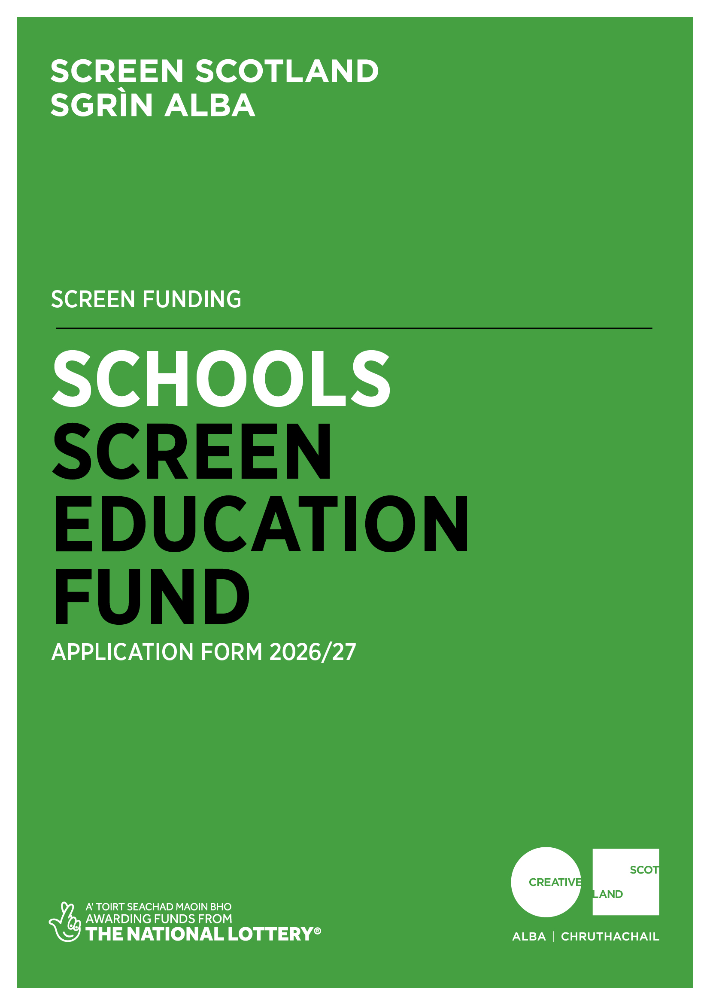
Application Form
Schools Screen Education Fund

Advice and Information

Please read the Schools Screen Education Fund Guidance before making an application.

If you have any general enquiries about the application process, guidelines or application form please contact us.

Alternative Formats and Languages
Our published materials, including funding guidance and application forms, are provided in alternative formats and languages. On request, they can be made available in other formats, as required.
We can accept applications and supporting materials which are written in English, Gaelic or Scots.
Access Support
Access support contributes to costs for services to help applicants overcome barriers to applying for our funds.
We offer access support to individuals or the lead applicant of a group who self-identify as d/Deaf, hard of hearing, disabled or living with chronic illness, mental illness or neurodivergence, such as dyslexia, autism or ADHD.
For information on the types of support available, how to request assistance and how to include access costs in your funding application please visit our website.
If you are a d/Deaf BSL user, you can access our services with the Contact Scotland-BSL programme. Visit www.contactscotland-bsl.org for more information.
Contacting our Enquiries Service
If you require technical support, further information or have any other queries, contact our Enquiries Service by emailing: enquiries@creativescotland.com

Application Questions

For us to be able to process your application, you need to complete all relevant sections of this application form.

Please be advised, we will not be able to process your application if you do not answer all the necessary questions.

Section A: Key Information
Please confirm that you have read the Schools Screen Education Fund Guidance before completing this application form. (Delete as appropriate) | Yes
 | No
Do you object to receiving funding from the UK National Lottery, for example for religious reasons? (Delete as appropriate) | Yes
 | No
Please confirm that you have read and understood Creative Scotland’s Funding Privacy Notice and any relevant information sheets before completing this application form. (Delete as appropriate)  You must answer this question for your application to proceed. | Yes
 | No
Did you contact a member of the Screen Education team in relation to this application? (Delete as appropriate) | Yes
 | No
Please provide brief details of what you discussed and the date of this contact:
Section B: Contact Information

All applicants must complete this section.

Part 1:
Name of School
Lead Contact Name and Position (if appropriate)
School Address
School Postcode
School Telephone Number
Lead Contact Email Address
School Web Address
Local Authority
Part 2:
What level of education does your school primarily provide?  Please type an X in as many boxes in the right hand column as apply. | Early Years
 | Primary
 | Secondary
 | Additional Support Needs
 | Other (please specify)

Section C: Project Summary
Summary of project
Title of Screen Education Project
Provide a brief summary of the activity you intend to undertake with this funding.

(100 words max)
When will the project start?
When do you expect the project to end?
Where will the project take place? | Locations
Where will the project take place? | Local authorities
Summary of project funding
What is the total budget of the project? |  | £
What is the funding you require from Screen Scotland? |  | £
What percentage is this of the total budget? |  | %
How much committed co-funding is in place? |  | £
What percentage is this of the total budget? |  | %
Does your school or local authority have a Safeguarding Policy with updated PVG legislation? |  | Yes
 |  | No

Section D: Project Overview

We will use your answers in this section to assess your application against the criteria and guidance as set out in the Schools Screen Education Fund Guidance. Please provide as much relevant detail as possible.
Question 1: Aims and objectives

Describe your screen education project — what it aims to achieve, who it’s for, and how it supports long-term impact in your school or local authority.

Guiding prompts:
- Summarise the project’s three key SMART (Specific, Measurable, Achievable, Relevant, Timebound) objectives for the project.
- Outline your project’s purpose, any innovative or evolving aspects, and connection to your school or local authority’s priorities.
- Describe your target participants and project timeline.

(350 words max)

Question 2: Project delivery and partnerships

Briefly describe how your project will be delivered, including who is involved and how you will manage and evaluate progress.
Guiding prompts:
- Outline key team members and any partner organisations, their roles, and what they bring to the project.
- Note any future potential for partnership or continued impact.

(350 words max)

3. Equalities, Diversity and Inclusion (EDI)

Explain how your project supports inclusion and achieves meaningful outcomes for participants.
Guiding prompts:
- Outline specific EDI objectives, access provisions, and how you will measure their impact.
Please confirm your school has an EDI Policy and outline how it will be reflected in the work.

(200 words max)

Section E: Supporting Material

Please note that the failure to provide any required supporting material may result in delays within the assessment process. If you are unsure about what supporting material you need to supply, please contact Screen Scotland’s Education Team.

Please supply the following material | Essential | Advise if the material is attached to the application or where we can access
Excel budget  (Please indicate all areas of income and expenditure and detail the budget headings) | Yes
CVs of key personnel | Yes
A copy of or weblink to your school/local authority’s Equalities and Diversity Policy or Equal Opportunities Policy. | Yes
Confirmation that your school or Local Authority’s has an environmental sustainability policy which will be adhered to throughout your project. | Yes | Yes/No (delete as appropriate)
Written evidence of any confirmed partnership funding (in-kind or cash) | If applicable
Letters of commitment from any partners | If applicable
Section F: Statement of Acceptance

Please state the name of the person who has completed the form. This person must be an authorised signatory of the company or organisation applying or, in the case of an individual applicant, by the person named in Section B, Part 1, of the contact information.

I hereby confirm that the information in this application the supporting documents is true and correct, and I acknowledge that it is my responsibility to inform you immediately of any changes which could affect the interpretation or context of the application, and I confirm I will undertake to do this.

I acknowledge that the terms and conditions of this application and any other information supplied and discussed regarding this application, the assessment and decision making process, or in connection with this transaction as a whole (“the Confidential Information”) is and shall remain strictly confidential. I confirm that I shall not disclose to any third party or make public the Confidential Information without Creative Scotland’s prior written approval.
I acknowledge that Creative Scotland will endeavour to keep all information provided securely, but as a Public Authority in terms of the Freedom of Information (Scotland) Act 2002, may be required to disclose certain information under the Act. Where I stipulate at the time of providing information to Creative Scotland that I believe the information should be considered exempt from disclosure under that Act, and a request to Creative Scotland is subsequently made for disclosure of same or all of that information, Creative Scotland will endeavour to discuss such disclosure with me prior to making its decision. I do, however, accept and acknowledge that the ultimate decision on disclosure rests solely with Creative Scotland regardless of any prior statements or requests I have issued.
I confirm that all cash and in-kind contributions from the company or my own personal resources stated in the funding plan section of this application form are correct and that I have the authorisation to allocate the sums stated and I am responsible for ensuring that adequate resources will remain available to meet these requirements. In the event of any changes to the sums indicated I will provide a signed letter of confirmation.

I acknowledge that Creative Scotland is obliged to comply with Money Laundering Regulations 2007 and the Proceeds of Crime Act 2002, and I will, if requested, provide ID verification from any investor or myself, where appropriate, to meet compliance requirements.
I acknowledge that once Creative Scotland have confirmed the Offer of Funding in writing (via email) that Creative Scotland have the right to publicise their Offer of Funding on the Creative Scotland website and through other Creative Scotland information channels. I understand that Creative Scotland’s Offer of Funding does not place Creative Scotland under any obligation to release funds until such time as all contractual negotiations are complete and Creative Scotland’s Conditions Precedent have been met and their Funding Agreements signed off.
I confirm that I will not make any public statements (or allow others to do so on my behalf) regarding Creative Scotland’s Offer of Funding until such time as Creative Scotland has authorised and approved the form and content of any public statement.

I confirm that I have the power to accept the award under the conditions set out in the Creative Scotland Guidance and in this Application Form.
I declare that I have read and understood the Creative Scotland Guidance, this Application Form and the Conditions of Funding of Creative Scotland.

I hereby confirm acceptance of the above Statement of Acceptance and all related documents. (double click and mark as checked)

Name of Authorised Person
Position of Authorised Person
Date

Please now submit your completed application form to: screen@creativescotland.com

You must also complete your Equalities Monitoring Form and email it along with your application form. Please note, the Equalities Monitoring Form is anonymous and will be processed separately from your application.

