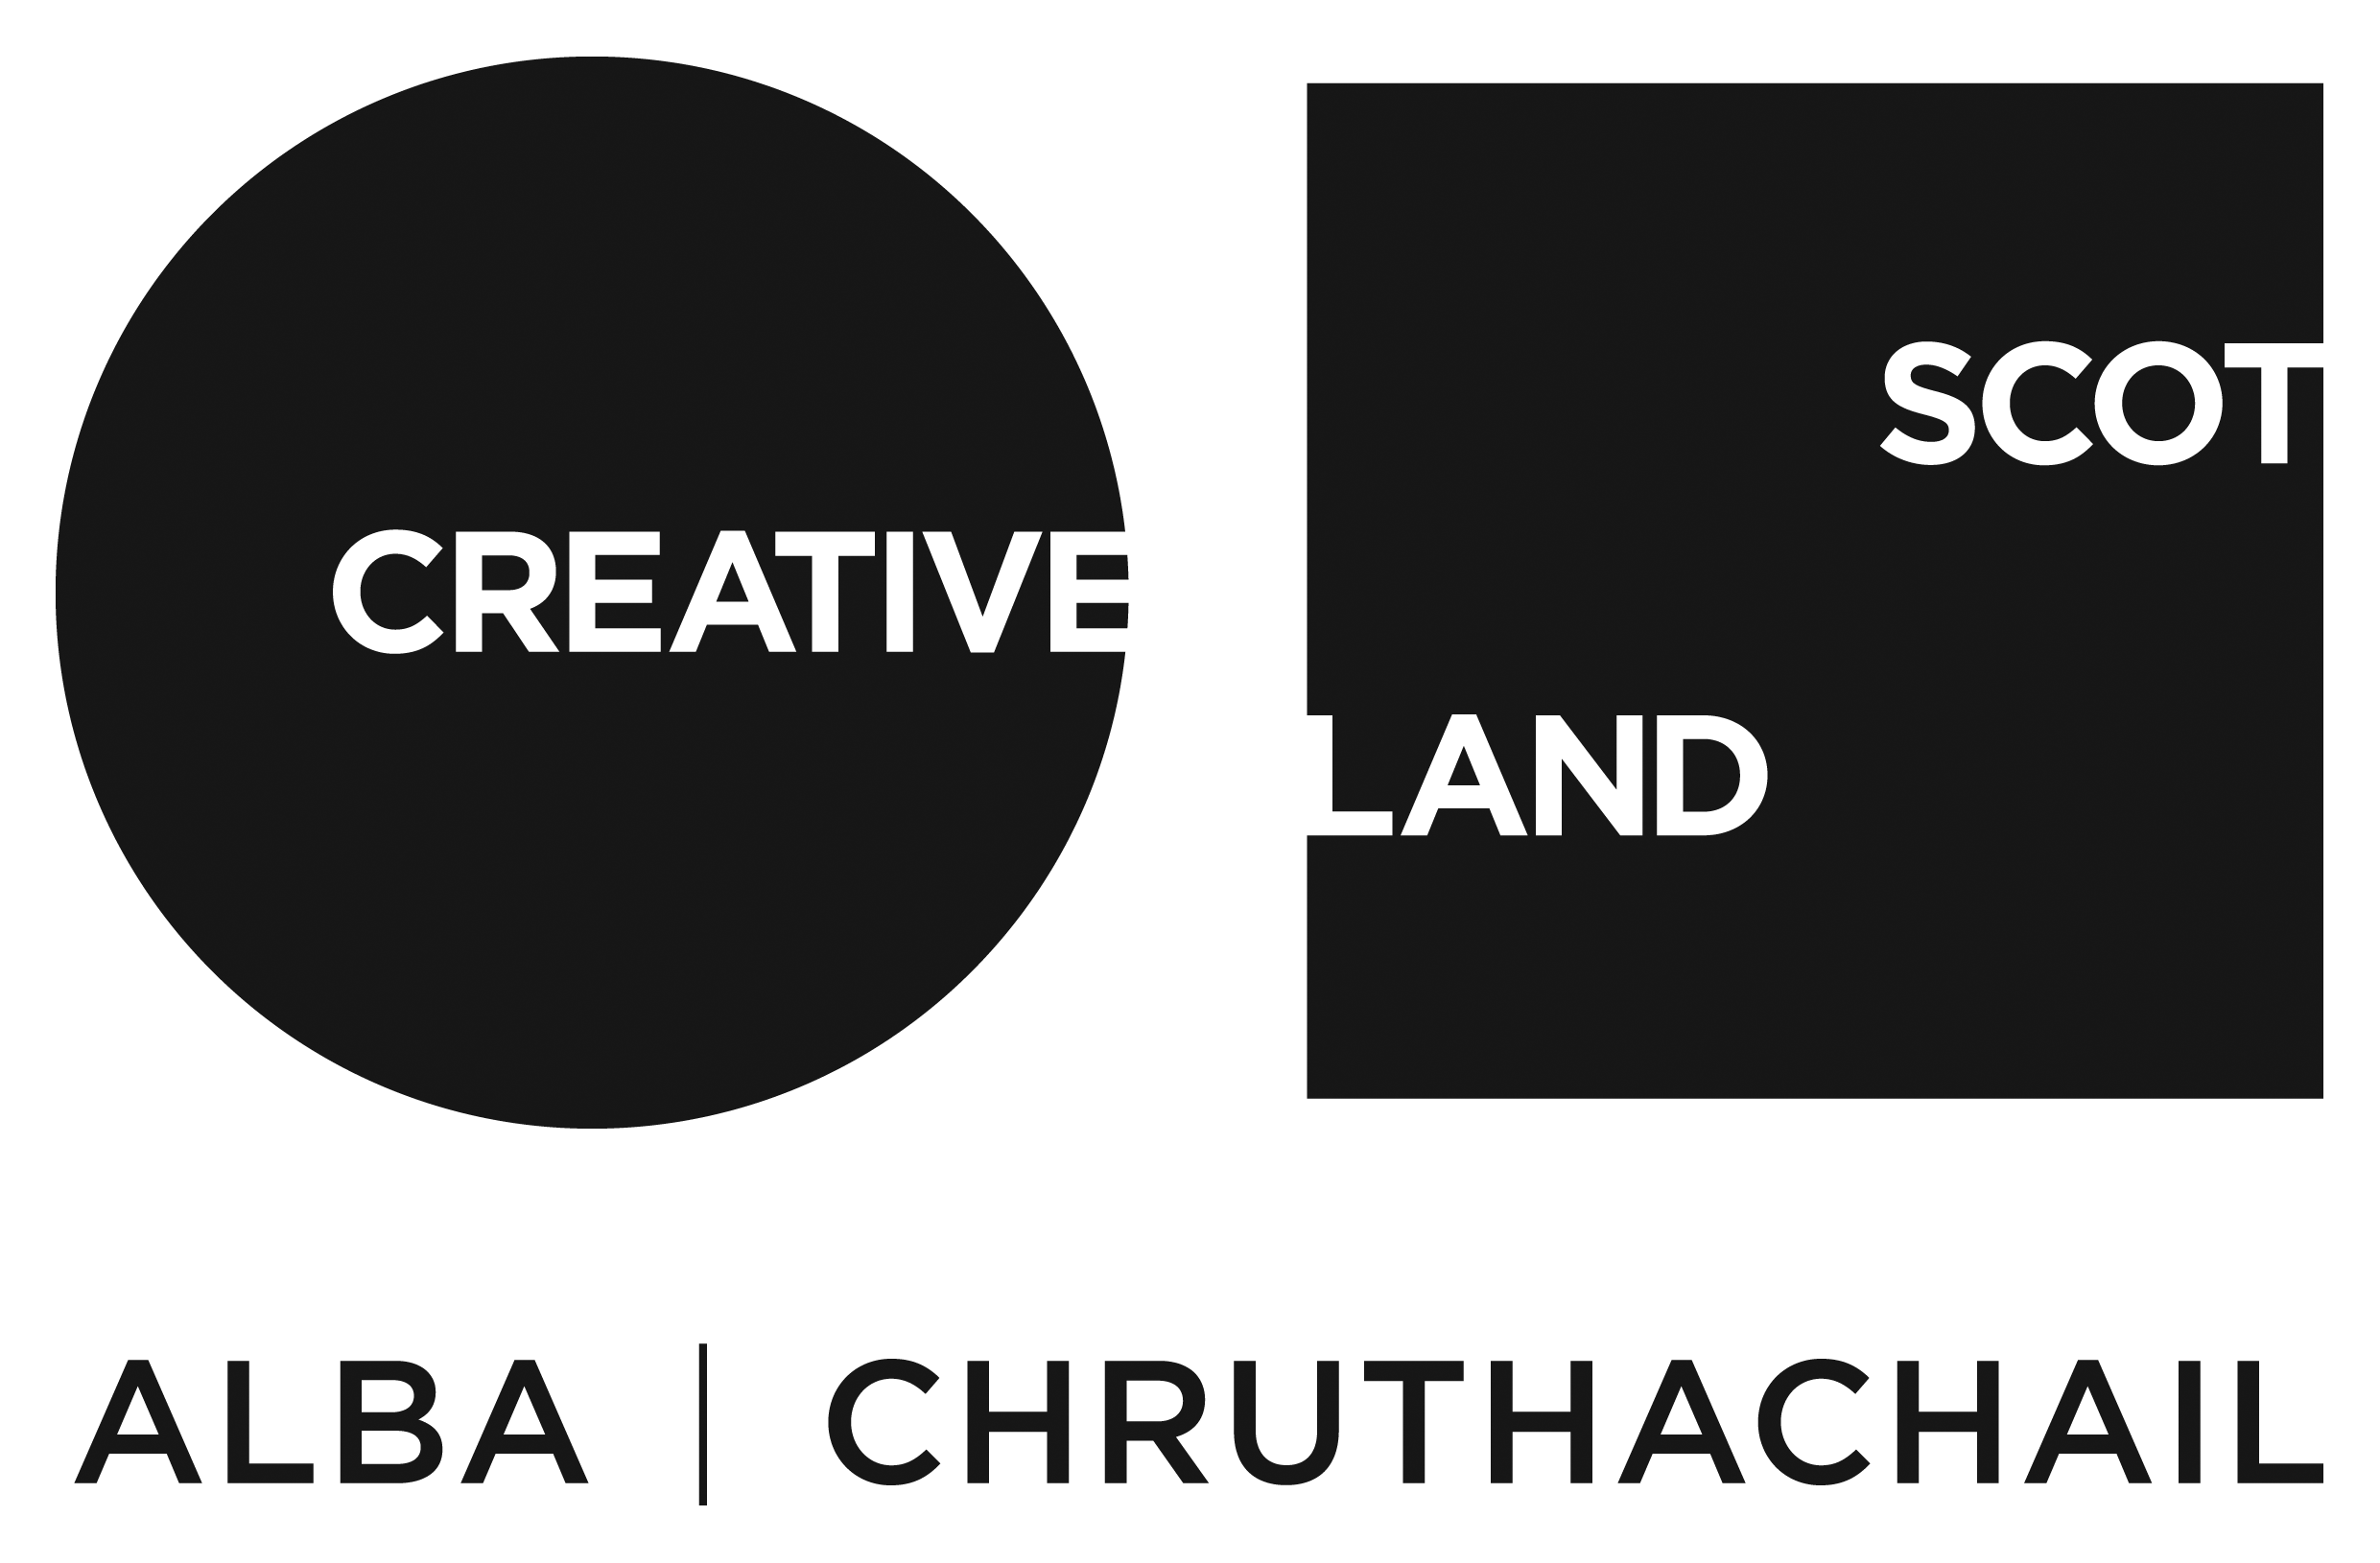
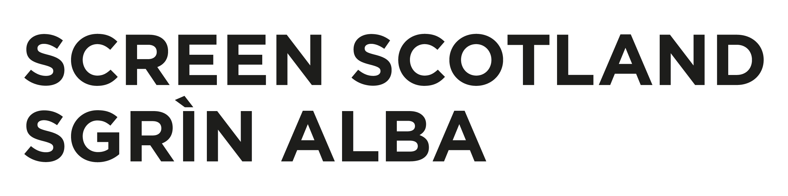

Creative Scotland and Screen Scotland
Equalities Monitoring Form

Who should complete this form?
All applicants who have applied for Creative Scotland/Screen Scotland funding are asked to complete this form, alongside your application form.

This Equalities Monitoring Form is used by Creative Scotland/Screen Scotland to give us essential statistical information about who our applicants are, and who we’re funding.

The Equalities Monitoring Form is anonymous and will on receipt be processed separately from your application. This data is managed confidentially, is not personally attributable and will have no bearing on your application for funding. Data is processed in accordance with the Data Protection Act. Please see our Privacy Policy for more information.

Alternative Formats and Languages
Our published materials, including funding guidance and application forms, can be made available in other formats as required. We can accept applications and supporting materials which are written in English, Gaelic or Scots.

To request materials in other formats or languages contact our Enquiries Service by emailing: enquiries@creativescotland.com

How to submit this form?
Please submit this completed form by email alongside your application form and supporting materials.
Equalities Monitoring Background
Creative Scotland and Screen Scotland puts equality at the heart of its activity, and we aim to acknowledge and reflect the diversity in Scotland today in all our work.

To monitor the type of applications we receive and the investments we award, we need to collect information which does not directly relate to our assessment of your application. We include questions on age, gender, ethnicity, disability, and sexual orientation - all defined ‘protected characteristics’ in The Equality Act 2010. We also include a question on Gaelic Language.

It is important that you provide this information to assist Creative Scotland/Screen Scotland’s reporting in line with the above act and to help us to improve our services.

In providing your completed response along with your application form, you are giving explicit consent for us to use this data for statistical reporting. The Equalities Monitoring Form is anonymous and will on receipt be processed separately from your application. This data is managed confidentially, is not personally attributable and will have no bearing on your application for funding. Data is processed in accordance with the Data Protection Act. Please see our Privacy Policy for more information.

If you do not know some of the information or if you prefer not to provide it, you can select 'prefer not to answer’.

If you are applying on behalf of an organisation, please ONLY answer
Section 1: Organisations

If you are applying as an individual, please ONLY answer
Section 2: Individuals

Please note, if you applied as a band, a collaboration or a group of two or more individuals working together on a project, each individual should separately complete Section 2: Individuals.

Section 1: Organisations
Please only complete this section if you applied as an Organisation.

Creative Scotland/Screen Scotland encourages organisations to collect employment data and monitor board membership. Please therefore tell us about your organisation.

If any of the categories are not relevant for your organisation please mark as N/A. For employees please include any permanent and/or freelance staff.

Funding Programme

Which funding programme have you applied to?

Age

 | Chair | Board Members | Chief Executive | Artistic Director/Lead | Employees | Volunteers
16-24 years
25-44 years
45-65 years
65+ years
Prefer not to say

Disability

Do you consider your organisation to be disabled-led | Yes ☐
Do you consider your organisation to be disabled-led | No ☐

 | Chair | Board Members | Chief Executive | Artistic Director/Lead | Employees | Volunteers
Disabled
Non-disabled
Not known
Prefer not to say
Gender

 | Chair | Board Members | Chief Executive | Artistic Director/Lead | Employees | Volunteers
Male
Female
Other
Prefer not to say

Ethnicity

Do you consider your organisation to be minority ethnic led? | Yes ☐
Do you consider your organisation to be minority ethnic led? | No ☐

Please indicate how many of your staff and board members are from the following ehtnic groups
 | Chair | Board Members | Chief Executive | Artistic Director/Lead | Employees | Volunteers
White Scottish/White British
Irish
Gypsy/Traveller
Polish
White Other (please specify)
Chinese/Chinese Scottish/Chinese British
African/African Scottish/African British
Caribbean/Caribbean Scottish/Caribbean British
Black/Black Scottish/Black British
Arab/Arab Scottish/Arab British
Mixed/Mulitple Ethnic Groups (please specify)
Other (please specify)
Prefer not to say

Sexual Orientation
Creative Scotland/Screen Scotland is a member of Stonewall’s Diversity Champions Programme. We therefore include the following question to monitor the degree to which our policies are gay-friendly.

Please indicate how many of your staff and board members are from the following groups.

 | Chair | Board Members | Chief Executive | Artistic Director/Lead | Employees | Volunteers
Heterosexual/Straight
Gay/Lesbian
Bisexual
Other
Prefer not to say

Gaelic Language

Do you support Gaelic Language through your organisation’s work | Yes ☐
 | No ☐

How many of your staff and board members regard themselves as Gaelic Speakers or Gaelic Learners?

 | Chair | Board Members | Chief Executive | Artistic Director/Lead | Employees | Volunteers
Gaelic Speaker(s)
Gaelic Learner(s)
Not known
Prefer not to say

Project Focus

Minority ethnic
Disabled people
LGBTQIA+
Gender Group
Children and Young People (0-25 years)
Older People
Faith/Religion
Health/Wellbeing

Section 2: Individuals
Please only complete this section if you applied as an individual.

Funding Programme

Which funding programme have you applied to?

Age

How old are you?
16-24 years | ☐
25-44 years | ☐
45-65 years | ☐
65+ years | ☐
Prefer not to say | ☐

Disability

Do you have any of the following conditions which have lasted, or are expected to last at least 12 months?
Non-disabled | ☐
Visual Impairment | ☐
Hearing Impairment/Deaf | ☐
Physical Disabilities | ☐
Cognitive or Learning Disablities | ☐
Mental Health Condition | ☐
Other Long Term/Chronic Condition | ☐
Other (please specify) | ☐
Prefer not to say | ☐

Ethnicity
What is your ethnic group? Please indicate which best describes your ethnic group or background
White Scottish/White British | ☐
Irish | ☐
Gypsy/Traveller | ☐
Polish | ☐
White Other (please specify) | ☐
Chinese/Chinese Scottish/Chinese British | ☐
African/African Scottish/African British | ☐
Caribbean/Caribbean Scottish/Caribbean British | ☐
Black/Black Scottish/Black British | ☐
Arab/Arab Scottish/Arab British | ☐
Mixed/Mulitple Ethnic Groups (please specify) | ☐
Other (please specify) | ☐
Prefer not to say | ☐
Gender

What is your gender?
Male | ☐
Female | ☐
Other | ☐
Prefer not to say | ☐

Sexual Orientation
Creative Scotland/Screen Scotland is a member of Stonewall’s Diversity Champions Programme. We therefore include the following question to monitor the degree to which our policies are gay-friendly.

Which of the following options best describes how you think of yourself?
Heterosexual/Straight | ☐
Gay/Lesbian | ☐
Bisexual | ☐
Other | ☐
Prefer not to say | ☐

Gaelic Language

Do you speak Gaelic? | Yes ☐
Do you speak Gaelic? | No ☐

Project Focus

Roughly, what percentage of your project has a specific focus on engaging the following groups?
Minority ethnic
Disabled people
LGBTQIA+
Gender Group
Children and Young People (0-25 years)
Older People
Faith/Religion
Health/Wellbeing

