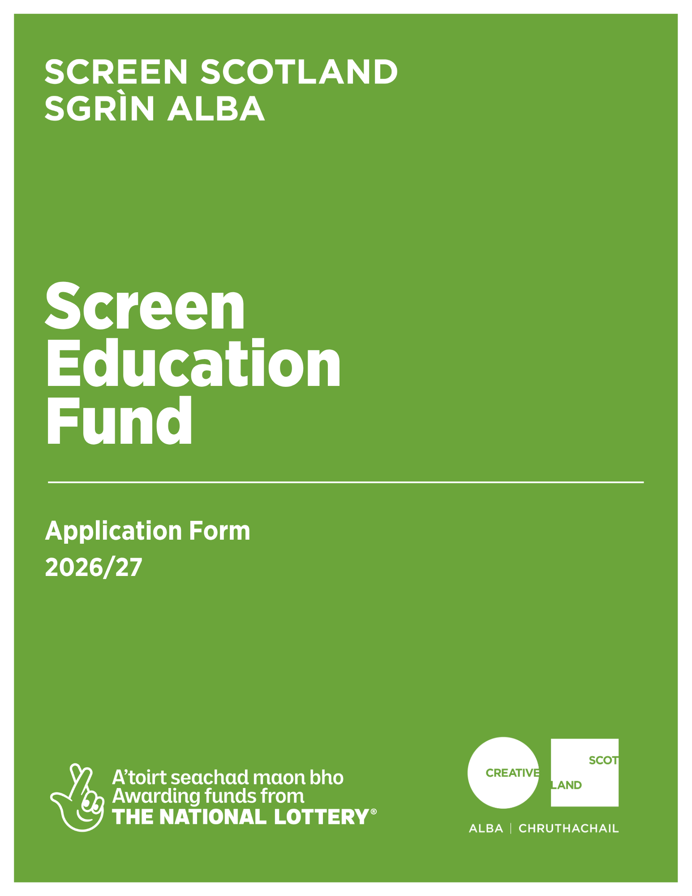

Application Form
Screen Education Fund
Advice and Information
Please read the Screen Education Fund guidance in full before making an application.
You must complete all relevant sections of this form and aim to keep responses clear and concise.
If you have any general enquiries about the application process, guidance or application form, please contact us.
Alternative Formats and Languages
Our published materials, including funding guidance and application forms, can be made available in other formats as required.
We can accept applications and supporting materials which are written in English, Gaelic or Scots.
To request materials in other formats or languages contact our Enquiries Service by emailing: enquiries@creativescotland.com
Access Support
We can help cover the cost of services that support you in applying for our funding. Access support is available to individuals or the lead applicant of a group who are defined as disabled under the Equality Act 2010, such as:
- d/Deaf
- Hard of hearing
- Disabled or living with chronic or mental illness
- Neurodivergence (e.g. dyslexia, autism or ADHD).

To find out what support is available, and how to request it please visit the Access Support section of our website.
If you have any questions, email us at: AccessSupportRequests@creativescotland.com
If you are a d/Deaf BSL user, you can access our services with the Contact Scotland-BSL programme. Visit www.contactscotland-bsl.org for more information.
Contacting our Enquiries Service
If you require technical support, further information or have any other queries, contact our Enquiries Service by emailing: enquiries@creativescotland.com

A: Declarations
I have read the Screen Education Fund Guidance | ☐
I have read Creative Scotland’s Privacy Notice | ☐
I am eligible to receive public funding, including National Lottery Funding | ☐
The proposed project has a clear learning focus | ☐
The proposed project start date is at least eight weeks after application submission date | ☐

Have you discussed this application with Screen Scotland? | Yes/No
If yes, please provide brief details and date discussed:

B: Applicant Details
Applicant name
This should be the individual authorised to submit and sign the application.
Organisation name (if applicable)
This should be the full legal name as per Companies House or OSCR Scotland.
Lead contact name and role
Address
Postcode
Telephone number
Email address
Website URL
If applying as an organisation
Please ensure this information matches Companies House or OSCR Scotland
Organisation type
Company number
Charity number

C: Project Summary
Project title
Project start date | DD/MM/YY
Project end date | DD/MM/YY
Project summary (200 words max)
Briefly describe what you will do, who it is for, what participants will gain and why this is important. Please clearly state whether this is participatory project, or professional learning provision for teachers or educators.
Project location(s) and
local authority areas
D: Budget Summary
Budgets should be proportionate and reflect fair and appropriate costs, including industry-standard pay where relevant.
Total project cost | £
Amount requested from Screen Scotland | £
Confirmed funding from other sources (if applicable) | £

E: Your Project
Need and Purpose (400 words max)

What need or opportunity does your project respond to? What do you want participants to learn, understand and gain through the activity?
Participants and Engagement (400 words max)

Who is the project for and why? Explain how you will recruit and engage participants, and the rationale for your project activity and how this has been shaped by their needs and context.
Activity and Delivery (400 words max)

What will happen during the project? Outline the key activities, delivery approach, timescale and key milestones.
Delivery Team (250 words max)

Who will deliver the project? Summarise the roles, responsibilities and relevant experience of the key tutors, practitioners or staff involved. CVs must be provided.
Project Management (250 words max)

How will the project be managed? Explain who have overall responsibility for the project, how progress will be monitored, any key risks or challenges and how these will be managed. A separate risk assessment is required to support your application.
Evaluation (300 words max)

How will you know if the project has been successful? Explain what outcomes you expect, how you will gather feedback and evidence, and how you will use learning from the project to inform future work.

F: Key Considerations
Equalities, Diversity and Inclusion and Access (300 words max)

Who may face barriers to taking part and what practical steps will you take to address these? Include any access costs included in your budget.
Environmental Sustainability (200 words max)

How will you reduce the environmental impact of your project in a practical and proportionate way?
Fair Work (200 words max)

How will you ensure fair pay and fair working practices?
Safeguarding (200 words max)

If your project involves children, young people or vulnerable adults, outline your safeguarding approach including policies, named responsibility or safer recruitment arrangements and PVG details.

G: Supporting Materials
Please confirm that you have provided the following supporting materials alongside your completed application form.
Detailed Project Budget | ☐
CVs of key personnel | ☐
Copy of your constitution or governing document  (if applying as an organisation) | ☐
Equalities, Diversity and Inclusion or Equal Opportunities Policy/Statement | ☐
Safeguarding Policy/Statement | ☐
Environmental Suatainability Policy/Statement | ☐
Letters of support/commitment from project partners | ☐
Confirmation of partnership funding | ☐
A risk assessment | ☐

Statement of Acceptance
PLEASE STATE THE NAME OF THE PERSON WHO HAS COMPLETED THE FORM. THIS PERSON MUST BE AN AUTHORISED SIGNATORY OF THE ORGANISATION APPLYING, OR BE THE PERSON NAMED IN SECTION A OF THE CONTACT DETAILS.
I hereby confirm that the information in this application submission including the supporting documents is true and correct and I acknowledge that it is my responsibility to inform you immediately of any changes which could affect the interpretation or context of the application, and I confirm I will undertake to do this.
I acknowledge that the terms and conditions of this application and any other information supplied and discussed regarding this application, the assessment and decision making process, or in connection with this transaction as a whole (“the Confidential Information”) is and shall remain strictly confidential.
I confirm that I shall not disclose to any third party or make public the Confidential Information without Creative Scotland’s prior written approval. I acknowledge that Creative Scotland will endeavour to keep all information provided securely, but as a Public Authority in terms of the Freedom of Information (Scotland) Act 2002, may be required to disclose certain information under the Act.
Where I stipulate at the time of providing information to Creative Scotland that I believe the information should be considered exempt from disclosure under that Act, and a request to Creative Scotland is subsequently made for disclosure of same or all of that information, Creative Scotland will endeavour to discuss such disclosure with me prior to making its decision. I do, however, accept and acknowledge that the ultimate decision on disclosure rests solely with Creative Scotland regardless of any prior statements or requests I have issued.
I confirm that all cash and in-kind contributions from the company or my own personal resources stated in the funding plan section of this application form are correct and that I have the authorisation to allocate the sums stated and I am responsible for ensuring that adequate resources will remain available to meet these requirements. In the event of any changes to the sums indicated I will provide a signed letter of confirmation. I acknowledge that Creative Scotland is obliged to comply with Money Laundering Regulations 2007 and the Proceeds of Crime Act 2002 and I will, if requested, provide ID verification from any investor or myself, where appropriate, to meet compliance requirements.
I acknowledge that once Creative Scotland have confirmed the Offer of Funding in writing (via email) that Creative Scotland have the right to publicise their Offer of Funding on the Creative Scotland website and through other Creative Scotland information channels. I understand that Creative Scotland’s Offer of Funding does not place Creative Scotland under any obligation to release funds until such time as all contractual negotiations are complete and Creative Scotland’s Conditions Precedent have been met and their Funding Agreements signed off.
I confirm that I will not make any public statements (or allow others to do so on my behalf) regarding Creative Scotland’s Offer of Funding until such time as Creative Scotland has authorised and approved the form and content of any public statement. I confirm that I have the power to accept the award under the conditions set out in the Creative Scotland Guidelines and in this Application Form.
I declare that I have read and understood the Creative Scotland Guidelines, this Application Form, Funding Privacy Notice and the Conditions of Funding of Creative Scotland.
I hereby confirm acceptance of the above Statement of Acceptance and all related documents. ☐
Name of authorised person:
Position of authoritsed person (if applicable):
Date: DD/YY/MM
Signature:
Please submit your completed application form to screen@creativescotland.com
Please now complete your Equalities Monitoring Form and email it along with your application form. Please note, the Equalities Monitoring Form is anonymous and will be processed separately from your application.

