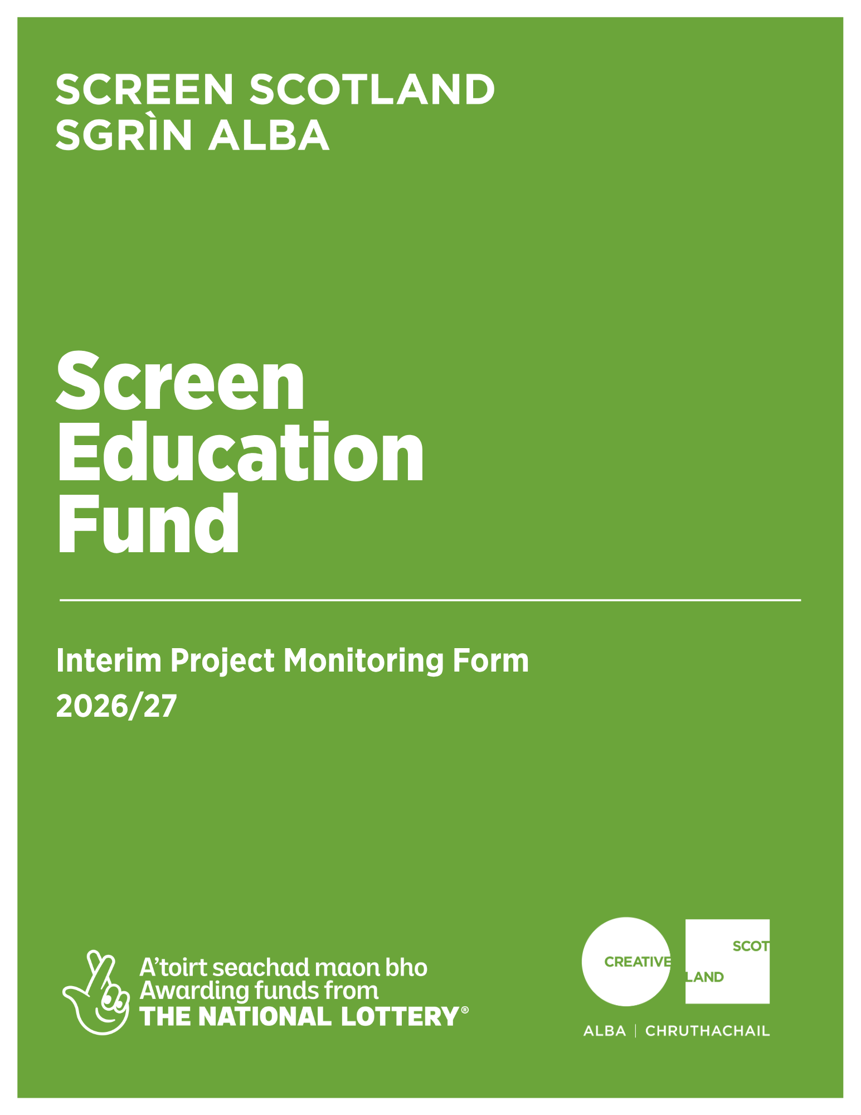

Interim Project Monitoring Form
Screen Education Fund 2026/27
Why do I need to complete this form?
This form provides an update on project progress and can support release of scheduled payments, where this is set out in the funding agreement.
Interim Project Monitoring is required for first-time funded projects or projects lasting longer than 9 months.
You must complete all relevant sections of this form and aim to keep responses clear and concise. If you are unsure what information is required or you have any questions, please contact your Lead Officer.
Important note, please only use this form where required by the funding agreement or requested by the Lead Officer.
A: Project Details
Project title
Applicant name
Project reference number
Project start date | DD/MM/YY
Project end date | DD/MM/YY

B: Progress Update
Briefly summarise the activity that has taken place so far (300 words max)

Include what has happened, where activity has taken place, and who has been involved.

C: Participants
Number of participants so far
This should be calculated based on the project overall and not aggregated. E.g. if you have 12 participants on a project who attend weekly for six weeks, the number of participants is 12, not 72.
Are you reaching your intended participants? | Yes/No
If not, briefly explain what has changed and how you are responding.
D: Delivery and Timeline
Explain whether the project is on track (250 words max)

Include any changes to activity, staffing, locations or timeline, and set out any revised delivery arrangements where relevant.

E: Outcomes to Date
What early outcomes or impacts have you observed so far? (250 words max)

Where possible, include any feedback or evidence gathered.

F: Risks and Challenges
Describe any challenges, delays or risks that have arisen and explain how you are managing them (250 words max)

G: Financial Update
Actual spend to date | £
Forecast final spend | £
Is project spend broadly in line with the approved budget? | Yes/No
If not, briefly explain any variations over 10%, underspend or overspend, how these are being managed (200 words max)

Any changes to your planned project must be agreed in advance with your Lead Officer.

H: Support Required
Do you require any additional support or input from Screen Scotland/Creative Scotland at this stage, beyond routine Lead Officer check ins?

I: Declaration
I hereby confirm that the information provided is accurate to the best of my knowledge ☐
Name of authorised person:
Position of authoritsed person (if applicable):
Date: DD/YY/MM
Signature:
Please submit your completed Interim Monitoring Form to screen@creativescotland.com

