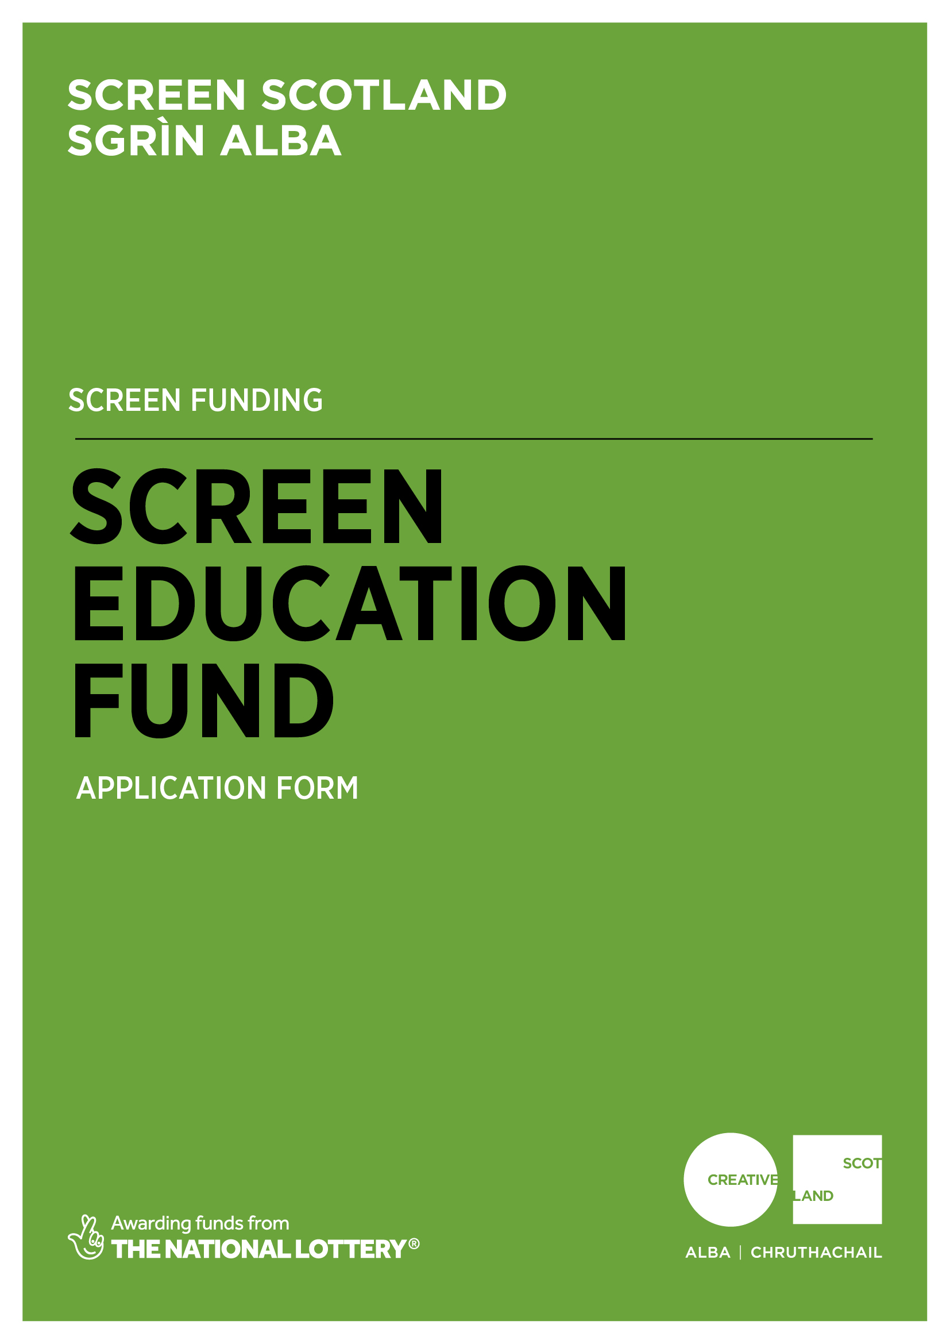
Application Form For
Screen Education Fund

Advice and Information
Please read the Screen Education Fund Guidance before making an application. If you have any general enquiries about the application process, guidelines or application form please contact us.
Alternative Formats, Languages and Access Support
Creative Scotland is committed to offering clear and accessible application processes and programmes that are open to everyone. On request this information is available in alternative formats including translations. We offer access support to disabled applicants, tailored to individual requests. Support includes Sign Language Interpreters for meetings and scribing support for dyslexic applicants. Officers can offer advice to new applicants and support them to make an application. The Equalities Team can offer additional one-to-one support to applicants with access requirements. Please note we will accept applications and supporting materials which are written in English, Gaelic or Scots.

If you have any general enquiries about the application process, Guidance or Application Form, please contact our Enquiries Service:
Email: enquiries@creativescotland.com

If you are a deaf BSL user, you can access our services with the Contact Scotland-BSL programme. Go to www.contactscotland-bsl.org/public for more information.

For us to be able to process your application, you need to complete Sections A-G of this application form.

Please be advised, we will not be able to process your application if you do not answer all the questions.

Section A: Key Information

Please confirm that you have read the Screen Education Fund Guidance before completing this application form. (Delete as appropriate.) | Yes
 | No
Do you object to receiving funding from the UK National Lottery, for example for religious reasons? (Delete as appropriate) | No
 | Yes
Please confirm that you have read and understood Creative Scotland’s Funding Privacy Notice and any relevant information sheets before completing this application form. (Delete as appropriate.)  Please note that you must answer this question for your application to proceed. | Yes
 | No
Have you discussed your proposal with a member of the Screen Education team at Screen Scotland? (Delete as appropriate.)  Please note that to be eligible to apply, you must answer yes to this question. | Yes
 | No
If YES, please provide details of who you have discussed your proposal with and the date(s) of this contact:

Section B: Contact Information

PART 1:
Name of Applicant
Lead Contact Name and Position (if appropriate)
Address
Postcode
Telephone Number
Email Address
Web Address
PART 2:
Trading Name of Organisation
What type of organisation are you? Please type an X in the box in the right-hand column.  (We need this information so we can determine if you are eligible to apply for Screen Funding.  We also need the information so we can monitor our decision making and report to Scottish Government and the National Lottery on the types of organisations we fund). | Company Limited by Guarantee
 | Company Limited by Shares
 | Scottish Charitable Incorporated Organisation (SCIO)
 | Community Interest Company (CIC)
 | Local Authority
 | Cultural and Leisure Trust
 | Public Sector Agency
 | Trust or Foundation
 | Unincorporated Association
Are you a registered company? (Delete as appropriate) |  |  | Yes
 |  |  | No
If you are a registered company, please provide your Registered Office address and Company Number.
Are you a registered charity? (Delete as appropriate) |  |  | Yes
 |  |  | No
If you are a registered charity, please provide your Registered Charity Number.

Section C: Project Summary

Name of Screen Education Project
Please summarise the activities you intend to undertake with this funding. If you are successful in receiving funding, we may use this information in any publicity we produce about your project.
(100 words max.)
What heading(s) best describe the kind of activity you will undertake with this funding? Please type an X in as many boxes in the right-hand column as apply. | CLPL for educators
 | Film education out with schools
 | Resource development
 | Participant feedback event
 | Celebration/Awards event
 | Festival
 | Competition
 | Other (please specify)
When will the project start?
When do you expect the project to end?
Where will the project take place?  (Please give us as much information as you can. We expect you to fill out at least one of these boxes, but please complete as many as are applicable.) | Post Codes: |  |  | Venue (if known):
 | Aberdeen | Dundee |  |  | Inverclyde | Shetland Islands
 | Aberdeenshire | East Ayrshire |  |  | Midlothian | South Ayrshire
 | Angus | East Dunbartonshire |  |  | North Ayrshire | South Lanarkshire
 | Argyll and Bute | East Lothian |  |  | North Lanarkshire | Stirling
 | City of Edinburgh | East Renfrewshire |  |  | Orkney Islands | The Highlands
 | Clackmannanshire | Falkirk |  |  | Perth and Kinross | Moray
 | Eilean Siar | Fife |  |  | Renfrewshire | West Dunbartonshire
 | Dumfries and Galloway | Glasgow City |  |  | Scottish Borders | West Lothian
 | Outside Scotland:
Summary of project funding
What is the total budget of the project? |  |  | £
What is the funding you require from Screen Scotland? |  |  | £
What percentage is this of the total budget? |  |  | %
How much committed co-funding is in place? |  |  | £
What percentage is this of the total budget? |  |  | %
Section D: Project Detail
We will use your answers in this section to assess your application against the criteria and guidance as set out in the Screen Education Fund Guidance. Please provide as much relevant detail as possible.

Project Outline
- What screen education activities will the partnership deliver? What is the proposed programme and timeline of delivery?
- Who are the target participants you hope to reach in the project? Why have you chosen this target group? How many participants do you aim to reach?
- What are the key aims and rationales for the project? What needs and opportunities have you identified which your project will address? What outcomes and impacts do you hope to achieve?
- What contributions will be made by any partners involved in this project? (You can provide details of partners and their previous work in the next section.)
- How will your project contribute to longer-term sustainability of screen education?
(1000 words max.)

Project Partnerships: Provide the name(s) and address(es) of any partner organisations/individuals collaborating in this project, including postcode.
Please provide details about each of your project partners.
- What previous/current screen education activities have they been involved with?
- What will each partner gain from the partnership work of this project?
- What potential is there for a sustained partnership after this project has been completed?
(200 words max.)
Project Management:
- Who is your project manager? What previous experience have they had in delivering similar projects?
- Who do you want to engage with and how do you intend to engage with them? How will you promote the project to potential participants?
- How will the project be monitored throughout its delivery? How will you gather data and information (e.g. attendance numbers, locations) throughout the project? (This may also be required for the Interim Project Monitoring Form.) Do you have a plan for any potential adjustments or issues that may arise?
(400 words max.)
End of Project Evaluation Strategy:
- How will you evaluate the project delivery and impact at its end? How does this fit with your stated key aims and rationale?
- How will you gather data and information (e.g. attendance numbers, location, impact) at the end of the project? What data will you produce and who will this be shared with?
- How will your evaluation support the longer-term sustainability of the project and/or its partnerships and/or screen education?
- What follow-up monitoring/support will you offer participants after the project/activity is complete?
(400 words max.)
Equalities, Diversity and Inclusion Strategy:
- How does your organisation and/or project address specific issues relating to EDI? For example, have you recently undertaken an Equalities Impact Assessment and/or produced a Diversities Action Plan? If so, what actions are you undertaking to address any issues that have arisen from these? How will your project address specific issues relating to EDI in screen education?
- What EDI and/or access provisions will your project need to address? Have these been costed and addressed within your budget?
- How are you going to monitor and evaluate the specific EDI impact of your project?
(400 words max.)

Research and Development: Screen Scotland would like to use your project as part of our ongoing research into and development of screen education. Please type an X in the box in the right-hand column for any material you intend to gather during and present at the end of your project.
Quantitative data (numbers: of participants reached…)
Qualitative data (descriptions: of skills gained…)
Anecdotal comments from participants
Photographs of activities in progress
Filmed footage (interviews with participants, activities in progress)
Documented case study of project (filmed and/or written)
Films made by participants resulting from the project
Follow-up assessment of project impact (between 6-12 months after project end date)

Section E: Funding/Income Table

This information will be used internally to help inform our work and to report to government and stakeholders.

Type of Funding | Name of funder / Source of income | Cash or in-kind? | Conditional, guaranteed or pending? | Amount of funding / income | % of total project cost
PUBLIC FUNDING
Creative Scotland / Screen Scotland | Screen Scotland | Cash | Pending
Local Authority
Local Enterprise Companies
Broadcasters
Other Lottery
Own resources (cash and/or in-kind, please specify)
Other
PRIVATE FUNDING
Trusts and foundations
Companies
Individuals and fundraising
Other (please specify)
Own resources (cash and/or in-kind: please specify)
EARNED INCOME / OTHER (please add rows as required)
E.g. Box office
Please specify:
Please specify:
TOTAL |  |  |  |  | 100%

Section F: Supporting Material

Please supply the following material | Essential | Please advise if the material is attached to the application or where we can access it
Detailed timeline of project delivery | Essential
Excel budget  (Please indicate all areas of income and expenditure and detail the budget headings, including EDI.) | Essential
CVs of key personnel | Essential
Detailed outline of project evaluation plans | Essential
Written evidence of any confirmed partnership funding (in-kind or cash) | Essential
Letters of commitment from any partners | Essential
A copy of founding legal documents (for example Articles of Association, Trust Deeds, or written constitution) | Essential
A copy of your Equalities and Diversity policy or Equal Opportunities Policy. | Essential
Section G: Statement of Acceptance

PLEASE STATE THE NAME OF THE PERSON WHO HAS COMPLETED THE FORM. THIS PERSON MUST BE AN AUTHORISED SIGNATORY OF THE COMPANY OR ORGANISATION APPLYING OR, IN THE CASE OF AN INDIVIDUAL APPLICANT, BY THE PERSON NAMED IN SECTION B, PART 1, OF THE CONTACT INFORMATION.

I hereby confirm that the information in this application the supporting documents is true and correct and I acknowledge that it is my responsibility to inform you immediately of any changes which could affect the interpretation or context of the application, and I confirm I will undertake to do this.

I acknowledge that the terms and conditions of this application and any other information supplied and discussed regarding this application, the assessment and decision making process, or in connection with this transaction as a whole (“the Confidential Information”) is and shall remain strictly confidential. I confirm that I shall not disclose to any third party or make public the Confidential Information without Creative Scotland’s prior written approval.
I acknowledge that Creative Scotland will endeavour to keep all information provided securely, but as a Public Authority in terms of the Freedom of Information (Scotland) Act 2002, may be required to disclose certain information under the Act. Where I stipulate at the time of providing information to Creative Scotland that I believe the information should be considered exempt from disclosure under that Act, and a request to Creative Scotland is subsequently made for disclosure of same or all of that information, Creative Scotland will endeavour to discuss such disclosure with me prior to making its decision. I do, however, accept and acknowledge that the ultimate decision on disclosure rests solely with Creative Scotland regardless of any prior statements or requests I have issued.
I confirm that all cash and in-kind contributions from the company or my own personal resources stated in the funding plan section of this application form are correct and that I have the authorisation to allocate the sums stated and I am responsible for ensuring that adequate resources will remain available to meet these requirements. In the event of any changes to the sums indicated I will provide a signed letter of confirmation.

I acknowledge that Creative Scotland is obliged to comply with Money Laundering Regulations 2007 and the Proceeds of Crime Act 2002 and I will, if requested, provide ID verification from any investor or myself, where appropriate, to meet compliance requirements.
I acknowledge that once Creative Scotland have confirmed the Offer of Funding in writing (via email) that Creative Scotland have the right to publicise their Offer of Funding on the Creative Scotland website and through other Creative Scotland information channels. I understand that Creative Scotland’s Offer of Funding does not place Creative Scotland under any obligation to release funds until such time as all contractual negotiations are complete and Creative Scotland’s Conditions Precedent have been met and their Funding Agreements signed off.
I confirm that I will not make any public statements (or allow others to do so on my behalf) regarding Creative Scotland’s Offer of Funding until such time as Creative Scotland has authorised and approved the form and content of any public statement.

I confirm that I have the power to accept the award under the conditions set out in the Creative Scotland Guidance and in this Application Form.
I declare that I have read and understood the Creative Scotland Guidance, this Application Form and the Conditions of Funding of Creative Scotland.

I hereby confirm acceptance of the above Statement of Acceptance and all related documents. (double click and mark as checked)

……………………………………………
Name of Authorised Person

……………………………………………
Position of Authorised Person

……………………………………………
Date

Please now submit your completed application form to: screen@creativescotland.com

Please also complete your Equalities Monitoring Form and email it along with your application form. Please note: the Equalities Monitoring Form is anonymous and will be processed separately from your application.

