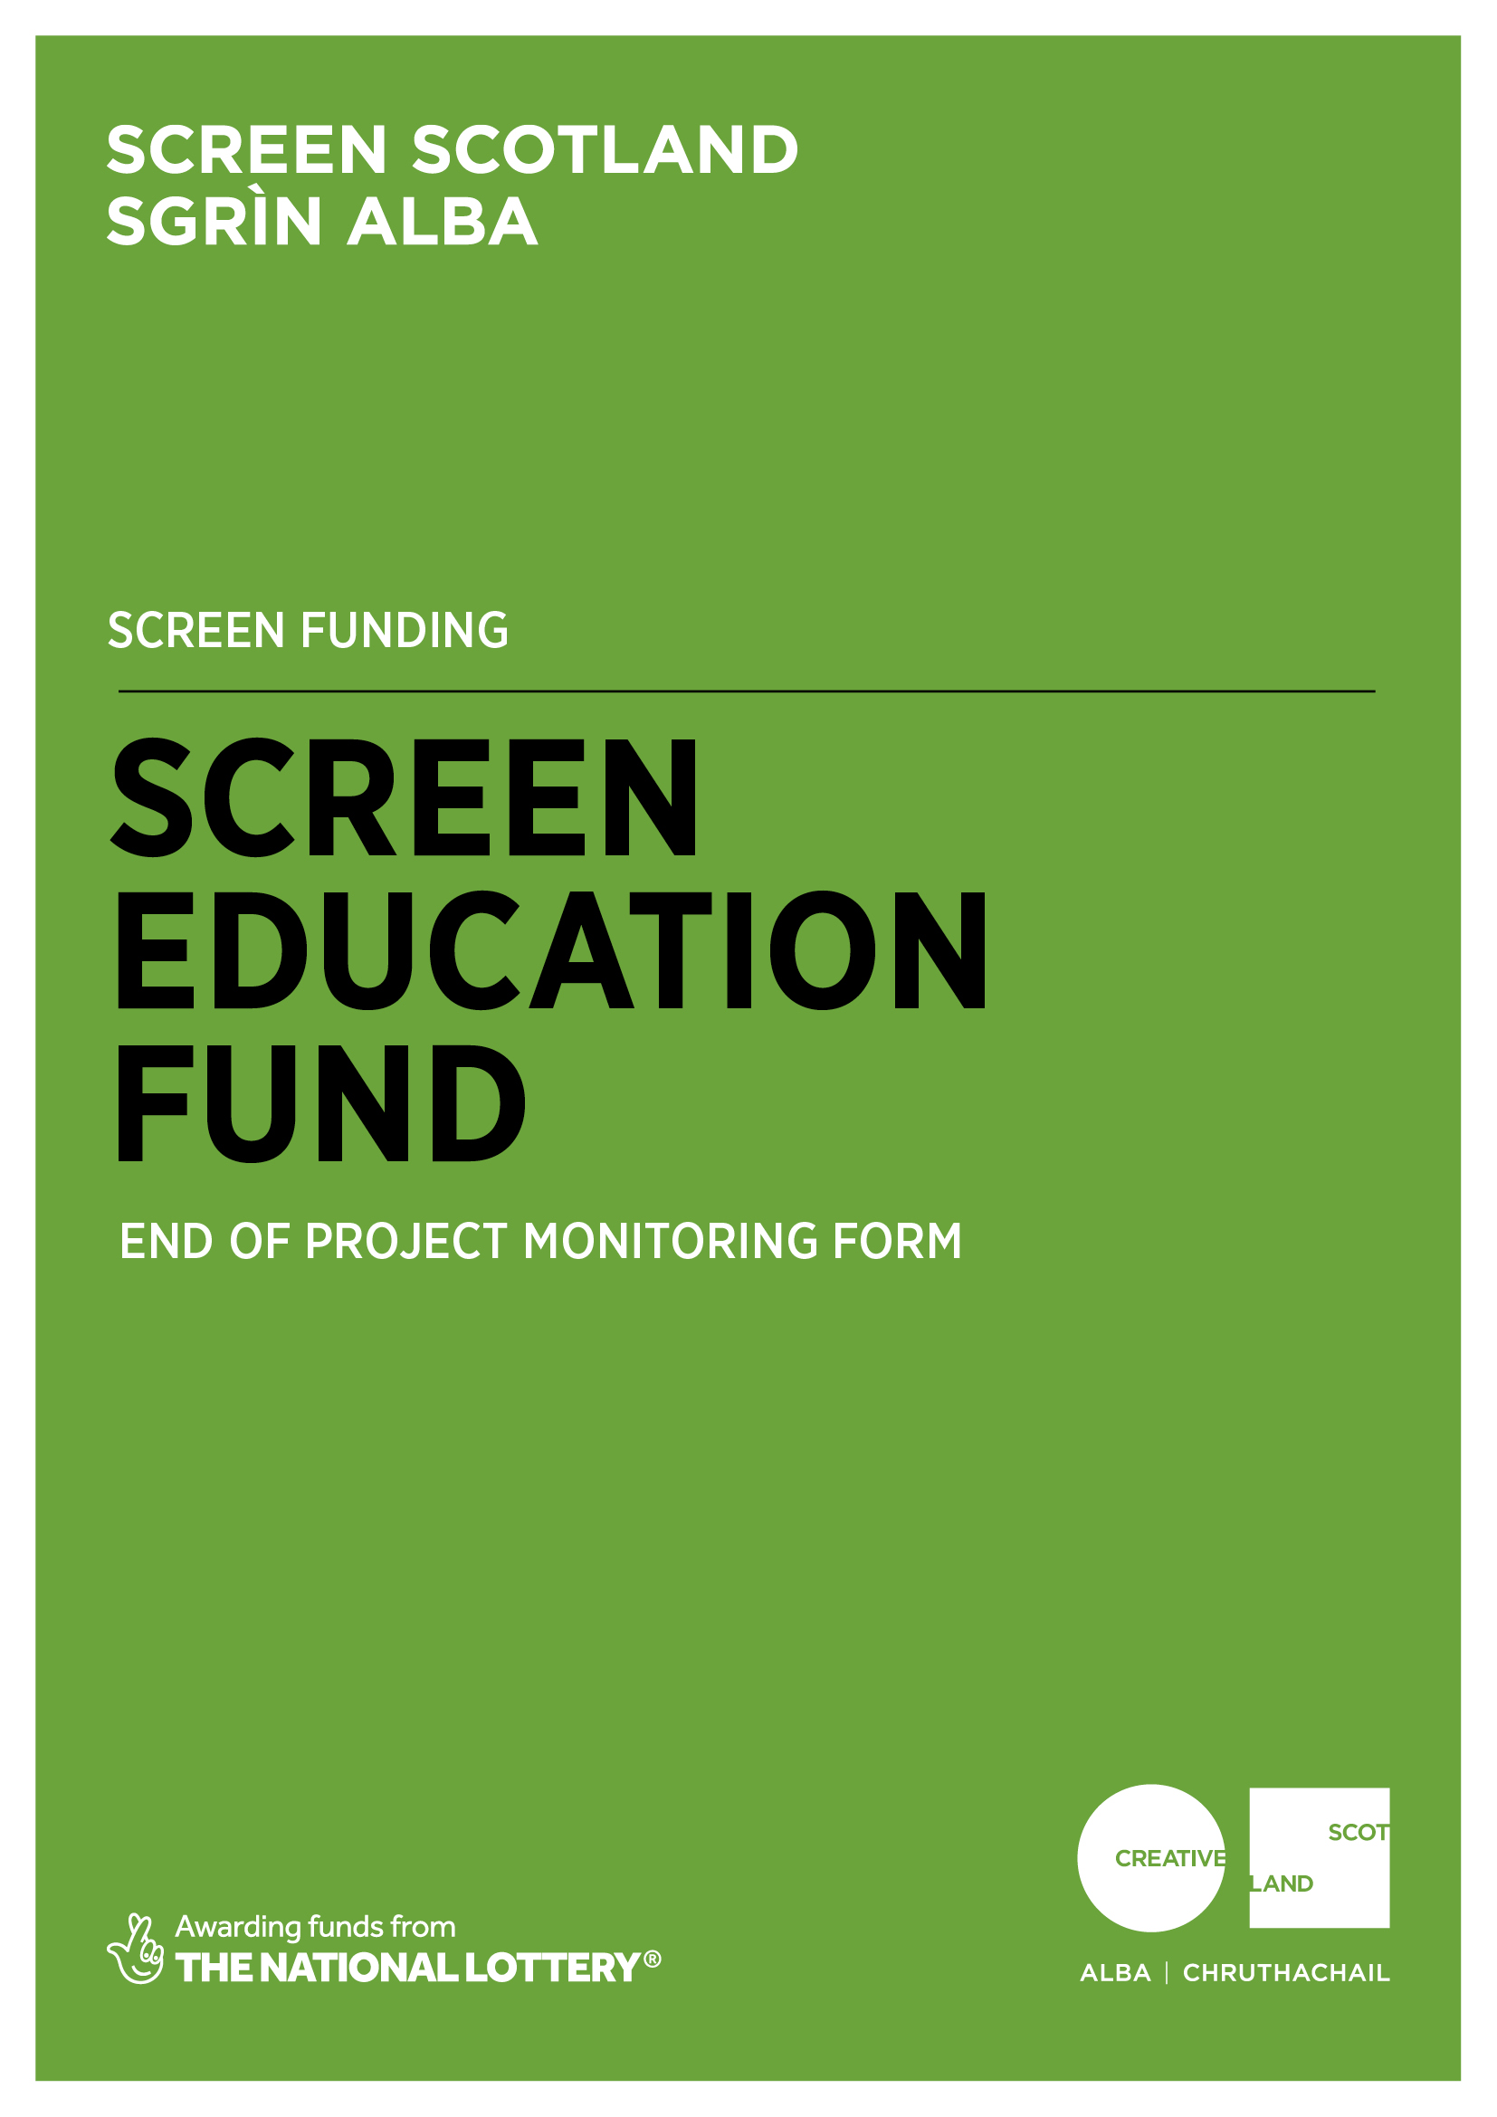
Why do I need to complete this form?

Screen Scotland is leading the growth of the sector through increased funding and support for film and television production, an increase in specialist staff and further investment in skills, festivals, audiences and education. Screen Scotland sits within Creative Scotland and is a partnership with Scottish Enterprise, Highlands and Islands Enterprise, Skills Development Scotland, Scottish Funding Council, with funding from the Scottish Government and the National Lottery.

To demonstrate the impact of our funding, we ask all those in receipt of support to help us – both by providing us with the data we need to show the reach and impact of the creative activity we support; and to tell us about the great work you do. We’re always looking to promote and advocate for the sector by showcasing success stories and case studies.

Completing this form will enable us to process any remaining payments outstanding as per the payment schedule agreed in your original funding agreement. And finally, this form is your chance to tell Screen Scotland how we did. Can we improve our processes, or make our information, guidance and support better?

When should I complete this form?

We ask that you complete and return this form to us at the conclusion of your funded activity to release your final payment. When answering the questions, please refer to your original application and the funding agreement you signed. Please note that for accounting and audit purposes, this form, and particularly the Certified Income and Expenditure statement, must be physically signed off by the lead contact for the application to indicate a true and accurate representation of income and expenditure. A scanned/electronic version of this signature is acceptable.

Once completed, you should return this form by email to:
screendeliverables@creativescotland.com

Please note that we prefer this form to be completed and returned by email. However, if you would like to send in a handwritten version, do so using BLACK INK and BLOCK CAPITALS throughout. You can post the form to:
Funding Team,
Creative Scotland,
Waverley Gate,
2-4 Waterloo Place,
Edinburgh,
EH1 3EG.

- Project Details
Project name: |  |  |  | Your project reference number:  (You will find this on the offer letter.)  CS-
Which funding programme did you receive support from? |  |  | Screen Education Fund
Please give the start and finish dates for the funded activity: |  |  |  | Start date:
 |  |  |  | Finish date:
If these were not the dates you originally outlined in your application, please briefly explain the reason for the change and describe any impact the change had on your project.

Where did your project take place? (Please give details of all locations in which activities took place.) | Postcodes of venues/ institutions | Venue Name |  | Postcode
 | Local authority areas (select all that apply) | Aberdeen | Dundee | Inverclyde | Shetland Islands
 |  | Aberdeenshire | East Ayrshire | Midlothian | South Ayrshire
 |  | Angus | East Dunbartonshire | North Ayrshire | South Lanarkshire
 |  | Argyll and Bute | East Lothian | North Lanarkshire | Stirling
 |  | City of Edinburgh | East Renfrewshire | Orkney Islands | The Highlands
 |  | Clackmannanshire | Falkirk | Perth and Kinross | Moray
 |  | Eilean Siar | Fife | Renfrewshire | West Dunbartonshire
 |  | Dumfries and Galloway | Glasgow City | Scottish Borders | West Lothian

- Review of Project
Project Delivery: Please refer to your funding application and reflect on the original aims of the project you received funding for.
- What were the biggest successes/gains/impacts of your project? How will these influence your future approach to film education?
- Did you face any challenges? How did you deal with these?
- Did you achieve your planned outcomes? If so, in what way? If not, what will you do differently in future?
- What contributions will your project make to the longer-term sustainability of film education? What long-term benefits will your project have on participants and/or your organisation?

Project Impact: Based on feedback from participants, what examples can you give of any impacts your project had? Are these the impacts you intended? Were there any unexpected impacts?
(If you have any supporting material which you would like to/are able to share (e.g. feedback surveys, case study material) please attach these as additional documents. We may use this material as part of our ongoing research into and development of film education. See page 14 for more information.)

Partnership Working: If this project involved any partnership, how did your partnership working evolve throughout the project? What did you gain from the partnership throughout the project? Did your partners change from your original application and, if so, how did this affect your project?

- Reaching people
Project Participation: Please refer to your funding application and reflect on the original groups you intended to target with the project you received funding for.
- Was the project able to reach the targeted participants?
- Did it benefit the public and/or the wider education sector?
- How did the reach of the project compare to what you anticipated when you applied?
- Were there any outcomes you did not anticipate?

Age Groups: How many people did you reach with your project from the following age groups? Please give accurate numbers where possible.

Early years  0-4 | Children  5-11 | Young people  12-17 | Young adults  18-25 | Adults  25-59 | Older adults  60+

Sector Groups: Did you reach people with your project from the following sectors? Please put an X in as many boxes as apply. If you can supply accurate numbers then please add them, but this is not a requirement.

Primary School | Secondary School | College/  University | Library | Cinema | Other

Underrepresented Groups: Did you reach people with your project from the following underrepresented groups? Please put an X in as many boxes as apply. If you can supply accurate numbers then please add them, but this is not a requirement.
children and young people
older people
care-experienced young people or young carers
faith and or religious groups
gender groups
sexuality, sexual orientation, and gender identity groups (LGBT+)
disabled people
deaf/hard of hearing/deafened people
visually impaired people
health and wellbeing groups
people with Autistic Spectrum Disorder
people with Dementia
Black, Asian or minority ethnic groups (BAME)
refugees, asylum seekers and/or travellers
additional language (Gaelic, BSL, minority language...)
specific location with transport and/or infrastructure issues
socially disadvantaged area or communities facing deprivation

Equalities, Diversity and Inclusion: Please refer to your funding application and reflect on the original aims you had to increase EDI with the project you were funded for.
- What EDI practices and policies did you implement?
- What did you learn and/or gain from developing and implementing these?
- What barriers and challenges did you encounter?
- What will you do differently next time? How can Screen Scotland support you in doing so?

- Financial Management
Please send a certified financial statement as a separate document, preferably using Microsoft Excel.
- Please include your project reference number on each page.
- Please include all income and expenditure, both cash and in-kind, using the headings given in your application form and in the same order.
- Where headings include different types of expenditure, you should provide a breakdown showing how the figure has been arrived at.

Please provide the following summary budget information.
Forecast total project cost | £
Actual total project cost | £
If there were any significant changes (over 10% variation) between actual and forecast figures, please detail these below. If costs increased, please tell us how you managed the shortfall.

If partnership funds were pending when we awarded your funding, did you achieve these funds as hoped and from where? If not, how did you managed the shortfall?
(Please note: when the final amount of your grant is calculated, if the project has achieved a surplus of funds because costs have reduced or income from other sources has increased, we may reduce our final payment or ask you to repay any overpaid sums as appropriate.)
Please provide any other feedback on your funded activity which you consider relevant or which we have specifically requested as a special condition of funding. (Please refer to your offer letter.)

- Review of the Process and Next Steps
Did you find the application and funding process clear? |  | Yes
 |  | No
Referring to your answer above, can you tell us more about how we did?
This can include how we present the information (in guidelines and online), the advice or guidance we give (through emails, speaking to our staff or the enquiry service), the assessment and decision-making process, the payment of funding, or any support during delivery of the project.

Would you like to see this project continue in some form? |  | Yes
 |  | No
Referring to your above answer, can you tell us about some potential future developments of this project?
What would you do to continue the project? How would this build on what was achieved in the project originally? Who would you aim to reach with this next stage?

Would you consider applying again to Screen Scotland for funding to continue this project in some form? |  | Yes
 |  | No
Referring to your above answer, can you tell us more about why you would or would not be interested in applying to Screen Scotland again for funding?

Signature:
Date:

Important information about the data you submit in this form:

Openness and accountability
Information supplied by you will be held in manual files. It will then be summarised and details transferred to a computer-based grants management system. Reports from the information you supply and from any comments made by external assessors and staff members are likely to be held on both manual and computer-based systems. The information you supply will be made available to those assessing any other grant applications you make.
Data protection
Data held on our grants management system is used for statistical and accounting purposes. We view your signature on your application form as acceptance of the use of your data outlined above.

What happens next?

Once completed, you should return this form by email to:
screendeliverables@creativescotland.com

Upon submission, you will get an automated response confirming that we have received the form. We will review your form and the Funding Team will then send the form to a relevant Screen Scotland Officer for checking, approval and sign off. Once signed off, this will trigger our Finance Team to issue any outstanding payments. This process will generally take 2-4 weeks but can take longer if information is incomplete or needs to be checked.

Alongside this, the form will be shared with Creative Scotland’s Knowledge and Research Team, whose role it is to gather the statistical data we need when we are asked to report on the work we do.

The Communications Team will also be given access to the form and they may contact you directly if they would like to run a feature or case study on you / your work. To be featured as a case study or to tell us more about your work please email Screen Scotland’s dedicated Digital Communications Officer on screen@creativescotland.com.

Feedback provided on how Screen Scotland can change or improve our processes will be added to a log of issues we keep for this purpose. This log is discussed regularly by a working group of staff who are continuously looking to improve our funding processes in response to feedback.

