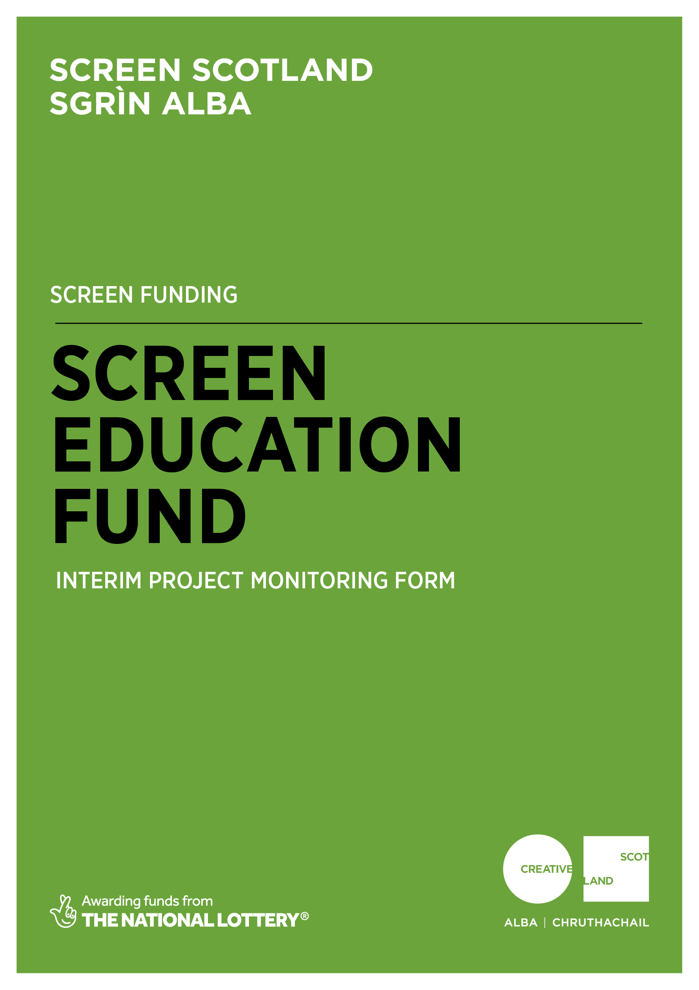
Why do I need to complete this form?

Screen Scotland is leading the growth of the sector through increased funding and support for film and television production, an increase in specialist staff and further investment in skills, festivals, audiences and education. Screen Scotland sits within Creative Scotland and is a partnership with Scottish Enterprise, Highlands and Islands Enterprise, Skills Development Scotland, Scottish Funding Council, with funding from the Scottish Government and the National Lottery.

To demonstrate the impact of our funding, we ask all those in receipt of support to help us – both by providing us with the data we need to show the reach and impact of the creative activity we support; and to tell us about the great work you do. We’re always looking to promote and advocate for the sector by showcasing success stories and case studies.

Completing this form will enable us to process any remaining payments outstanding as per the payment schedule agreed in your original funding agreement. And finally, this form is your chance to tell Screen Scotland how we did. Can we improve our processes, or make our information, guidance and support better?

When should I complete this form?

You should only complete this form when your funding agreement stipulates that we require you to submit an Interim Project Monitoring Report. If you are unsure whether this applies to you, please check the Funding Instalments section of your funding agreement.

Please note that for accounting and audit purposes, this form, and particularly the Certified Income and Expenditure statement (Appendix 1), must be physically signed off by the lead contact for the application to indicate a true and accurate representation of income and expenditure. A scanned/electronic version of this signature is acceptable.

Once completed, you should return this form by email to:

screendeliverables@creativescotland.com

Please note that we prefer this form to be completed and returned by email. However, if you would like to send in a handwritten version, do so using BLACK INK and BLOCK CAPITALS throughout. You can post the form to:
Funding Team,
Creative Scotland,
Waverley Gate,
2-4 Waterloo Place,
Edinburgh, EH1 3EG.

- Project Details
Project name: |  | Your project reference number:  (You will find this on the offer letter.)  CS-
Which funding programme did you receive support from? | Screen Education Fund
Please give the start and finish dates for the funded activity: |  | Start date:
 |  | Finish date:
If these are not the dates you originally outlined in your application, please briefly explain the reason for the change and describe any impact the change had on your project.

- Please provide a brief description of the activity you were funded to undertake as described to us in your application.

- Please summarise the activity which has taken place to date.
- What has happened, where it has happened, who has been involved as artists, tutors, participants etc.
- The impact your film education project is having on the participants.
Please enclose details of audience, participants or other third-party feedback on the project activity to date.

- Please describe the extent to which you are meeting your original objectives. If you are experiencing any difficulties with the project, tell us what these are and how you intend to proceed.
If the difficulties are significant and changes need to be made to your project, we will do our best to support you, but you must talk to a member of the Screen Scotland Film Education team before proceeding.
- Please list the activity you have planned over the next few weeks and months, before your next scheduled report.
Please include, for example, dates and venues of events such as exhibitions, performances, blog posts, Twitter, Vimeo, workshops, any press activity, etc.

- Financial Management
Please send a certified interim financial statement as a separate document, preferably using Microsoft Excel.
- Please include your project reference number on each page.
- Please include all income and expenditure, both cash and in-kind, using the headings given in your application form and in the same order.
- Where headings include different types of expenditure, you should provide a breakdown showing how the figure has been arrived at.

Please provide the following summary budget information.
Forecast total project expenditure to date | £
Actual total project expenditure to date | £
Forecast total project income to date | £
Actual total project income to date | £
If there were any significant changes (over 10% variation) between actual and forecast figures, please detail these below. If costs increased, please tell us how you managed the shortfall.

If partnership funds were pending when we awarded your funding, did you achieve these funds as hoped and from where? If not, how did you manage the shortfall?
(Please note: when the final amount of your grant is calculated, if the project has achieved a surplus of funds because costs have reduced or income from other sources has increased, we may reduce our final payment or ask you to repay any overpaid sums as appropriate.)
Please provide any other feedback on your funded activity which you consider relevant or which we have specifically requested as a special condition of funding. (Please refer to your offer letter.)
Signature:
Date:

Important information about the data you submit in this form:

Openness and accountability
Information supplied by you will be held in manual files. It will then be summarised and details transferred to a computer-based grants management system. Reports from the information you supply and from any comments made by external assessors and staff members are likely to be held on both manual and computer-based systems. The information you supply will be made available to those assessing any other grant applications you make.
Data protection
Data held on our grants management system is used for statistical and accounting purposes. We view your signature on your application form as acceptance of the use of your data outlined above.

What happens next?

Once completed, you should return this form by email to:

screendeliverables@creativescotland.com

Upon submission, you will get an automated response confirming that we have received the form. We will review your form and the Funding Team will then send the form to a relevant Screen Scotland Officer for checking, approval and sign off. Once signed off, this will trigger our Finance Team to issue any payments which are attached to the completion of this form. This process will generally take 2-4 weeks but can take longer if information is incomplete or needs to be checked.

